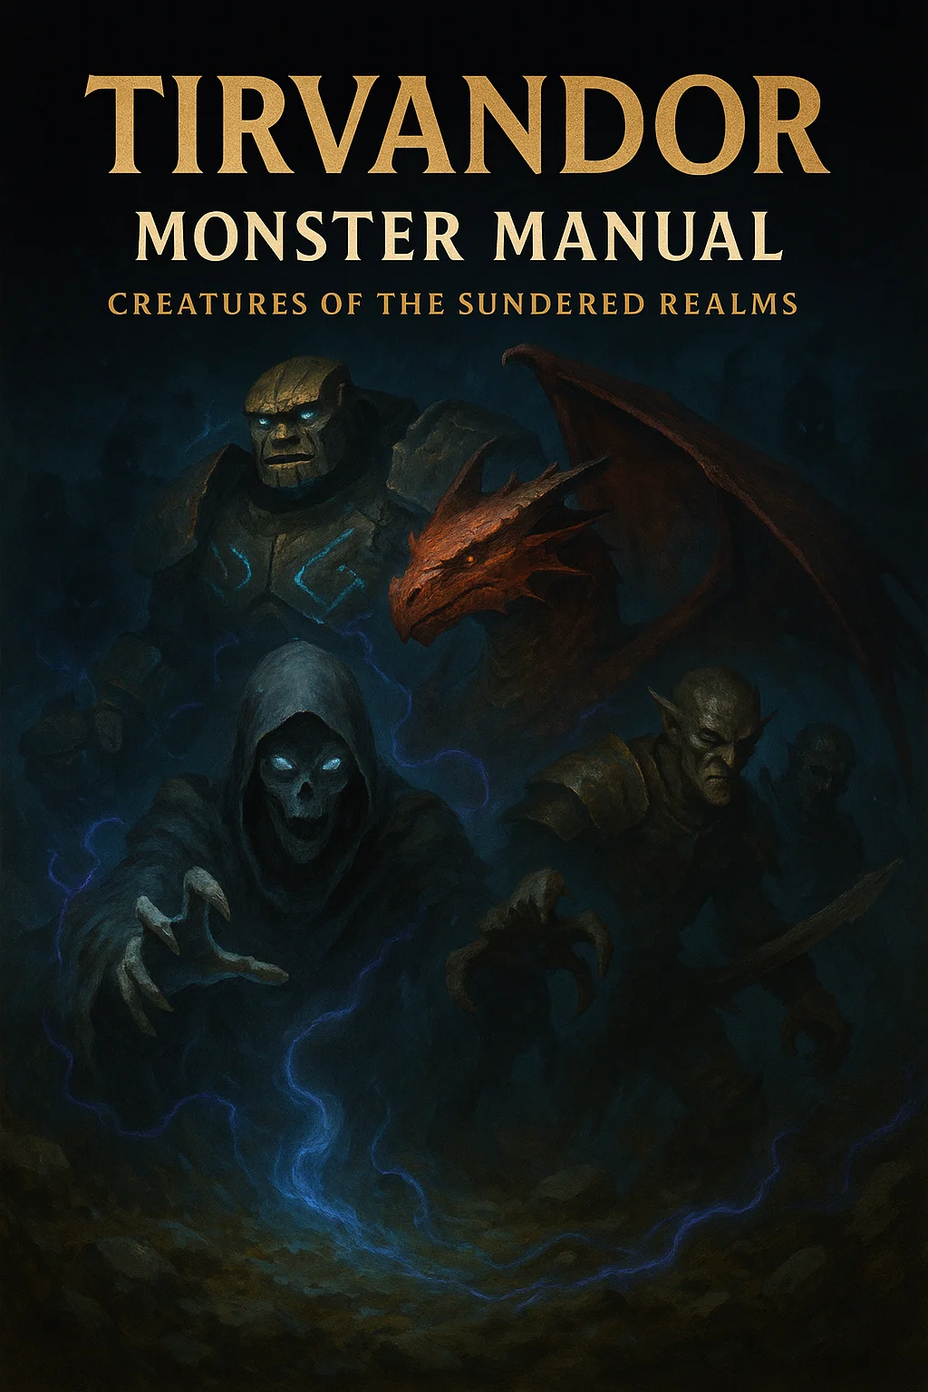

Table of Contents

Introduction 3

Border Creatures 4

Border Bandit 5

Smuggler Captain 6

War Scarred Veteran 8

Border Wraith 11

Contested Land Elemental 14

Refugee Mob 17

Scavenger Ghoul 19

Territorial Drake 21

War Beast 23

Haunted Battlefield 25

Thaldros Military 27

Thaldros Conscript 27

Thaldros Soldier 29

Iron Legion Enforcer 31

Royal Guard Elite 33

State Inquisitor 36

War Mage Of Thaldros 39

Siege Golem 42

General's Champion 44

Iron Crown Knight 46

Lord Commander Varius 49

Aethoria Resistance 52

Aethorian Militia 52

Resistance Fighter 54

People's Champion 56

Revolutionary Mage 58

Chain Breaker Monk 60

Guerrilla Commander 62

The Liberator 64

Prophesied Hero 66

Iron Guild Mercenaries 68

Guild Recruit 68

Veteran Mercenary 70

Guild Enforcer 72

Contract Killer 74

Iron Guild Captain 76

Guildmaster's Elite 78

Garrick Ironheart (guildmaster) 80

Ascended-Touched 81

Blessed Paladin 81

Thandros's Justicar 83

Aethor's Liberator 85

Moira's Seer 87

Sylvara's Wild Hunter 89

Sera's Mercy 91

Mordain's Sentinel 93

Fallen Champion 95

Ancient & Prophecy 97

Ancient Guardian 97

Prophecy Keeper 99

Forgotten King 101

Herald Of The Seven 103

Corrupted & Cursed 105

Corruption Spawn 105

War Twisted Soldier 107

Curse Bearer 109

# Introduction

This Monster Manual contains creatures unique to Tirvandor. Each entry includes complete D&D 5e stat blocks, tactical notes, and world integration.  
  
Creatures are organized by region for easy campaign integration.

# Border Creatures

These creatures are found in the Border region between Thaldros and Aethoria

|  |  |  |  |  |  |
| --- | --- | --- | --- | --- | --- |
| Medium humanoid (any race), any non-lawful alignment | | | | | |
| Armor Class 12 (leather armor) | | | | | |
| Hit Points 11 (2d8 + 2) | | | | | |
| Speed 30 ft. | | | | | |
| **STR** | **DEX** | **CON** | **INT** | **WIS** | **CHA** |
| 11 (+0) | 14 (+2) | 12 (+1) | 10 (+0) | 10 (+0) | 10 (+0) |
| Skills Stealth +4, Deception +2 | | | | | |
| Senses passive Perception 10 | | | | | |
| Languages Common | | | | | |
| Challenge 1/2 (100 XP) | | | | | |
| Border Cunning. The bandit has advantage on Stealth checks in the Border region's ruins and wilderness. | | | | | |
| Desperate Fighter. When reduced to half hit points or less, the bandit's next attack deals an extra 1d6 damage. | | | | | |
| **ACTIONS** | | | | | |
| Scimitar. Melee Weapon Attack: +4 to hit, reach 5 ft., one target. Hit: 5 (1d6 + 2) slashing damage. | | | | | |
| Light Crossbow. Ranged Weapon Attack: +4 to hit, range 80/320 ft., one target. Hit: 6 (1d8 + 2) piercing damage. | | | | | |
| **LORE** | | | | | |
| Border bandits are desperate refugees, deserters, or opportunists who prey on travelers in the contested lands. They know the terrain intimately and fight with the desperation of those with nothing left to lose. | | | | | |
| **TACTICS** | | | | | |
| - Use terrain for ambushes | | | | | |
| - Target weakest-looking party member | | | | | |
| - Flee when outnumbered or badly wounded | | | | | |
| - May surrender if offered mercy | | | | | |

## Border Bandit

## Smuggler Captain

|  |  |  |  |  |  |
| --- | --- | --- | --- | --- | --- |
| Medium humanoid (any race), any alignment | | | | | |
| Armor Class 15 (studded leather) | | | | | |
| Hit Points 58 (9d8 + 18) | | | | | |
| Speed 30 ft. | | | | | |
| **STR** | **DEX** | **CON** | **INT** | **WIS** | **CHA** |
| 12 (+1) | 16 (+3) | 14 (+2) | 14 (+2) | 12 (+1) | 14 (+2) |
| Saving Throws Dexterity +5, Intelligence +4  Skills Deception +6, Insight +3, Persuasion +6, Stealth +5  Senses passive Perception 11  Languages Common, Thieves' Cant, plus two others | | | | | |
| Challenge 3 (700 XP) | | | | | |
| Cunning Action. On each of its turns, the captain can use a bonus action to take the Dash, Disengage, or Hide action.  Border Network. The captain knows safe routes through the Border and has contacts in most settlements. Can call for reinforcements (1d4 border bandits arrive in 1d4 rounds).  Sneak Attack (1/Turn). The captain deals an extra 10 (3d6) damage when hitting with a weapon attack and has advantage on the attack roll. | | | | | |
| **ACTIONS** | | | | | |
| Multiattack. The captain makes two attacks with their rapier.  Rapier. Melee Weapon Attack: +5 to hit, reach 5 ft., one target. Hit: 7 (1d8 + 3) piercing damage.  Hand Crossbow. Ranged Weapon Attack: +5 to hit, range 30/120 ft., one target. Hit: 6 (1d6 + 3) piercing damage.  Contract Offer (Recharge 5-6). The captain offers a bargain. One humanoid within 30 feet that can hear the captain must make a DC 14 Wisdom saving throw. On a failure, the target is charmed for 1 minute or until the captain or their allies harm it. While charmed, the target is inclined to accept reasonable deals. | | | | | |
| **REACTIONS** | | | | | |
| Parry. The captain adds 2 to their AC against one melee attack that would hit them. To do so, the captain must see the attacker and be wielding a melee weapon. | | | | | |
| **LORE** | | | | | |
| Smuggler captains run illicit goods across the Borderweapons, refugees, contraband, and information. They're neutral parties in the conflict, caring only for profit, but their networks make them valuable allies or dangerous enemies. | | | | | |
| **TACTICS** | | | | | |
| - Negotiate before fighting if possible | | | | | |
| - Use Cunning Action to stay mobile | | | | | |
| - Call for backup if losing | | | | | |
| - Always have an escape route planned | | | | | |

## War Scarred Veteran

|  |  |  |  |  |  |
| --- | --- | --- | --- | --- | --- |
| Medium humanoid (any race), any alignment | | | | | |
| Armor Class 17 (half plate) | | | | | |
| Hit Points 68 (8d8 + 32) | | | | | |
| Speed 30 ft. | | | | | |
| **STR** | **DEX** | **CON** | **INT** | **WIS** | **CHA** |
| 16 (+3) | 13 (+1) | 18 (+4) | 10 (+0) | 12 (+1) | 10 (+0) |
| Saving Throws Strength +5, Constitution +6 | | | | | |
| Skills Athletics +5, Intimidation +2, Survival +3 | | | | | |
| Condition Immunities frightened | | | | | |
| Senses passive Perception 11 | | | | | |
| Languages Common | | | | | |
| Challenge 4 (1,100 XP) | | | | | |
| Survivor. The veteran has advantage on death saving throws. | | | | | |
| Seen It All. The veteran is immune to being frightened and has advantage on saving throws against being charmed. | | | | | |
| Battle Scarred. When the veteran takes damage that would reduce them to 0 hit points, they can make a DC 10 Constitution saving throw. On a success, they drop to 1 hit point instead. This DC increases by 5 each time this feature is used and resets after a long rest. | | | | | |
| **ACTIONS** | | | | | |
| Multiattack. The veteran makes two longsword attacks or two longbow attacks. | | | | | |
| Longsword. Melee Weapon Attack: +5 to hit, reach 5 ft., one target. Hit: 7 (1d8 + 3) slashing damage, or 8 (1d10 + 3) slashing damage if used with two hands. | | | | | |
| Longbow. Ranged Weapon Attack: +3 to hit, range 150/600 ft., one target. Hit: 5 (1d8 + 1) piercing damage. | | | | | |
| Intimidating Presence (Recharge 5-6). The veteran roars a challenge. Each enemy within 30 feet that can see or hear the veteran must make a DC 13 Wisdom saving throw or become frightened for 1 minute. A frightened creature can repeat the save at the end of each of its turns, ending the effect on a success. | | | | | |
| **LORE** | | | | | |
| These veterans have fought in countless Border skirmishes for both sides, mercenary bands, or their own survival. They're hard as nails, cynical, and incredibly difficult to kill. Many become mercenaries, bandits, or hermits. | | | | | |
| **TACTICS** | | | | | |
| - Fight defensively, conserving energy | | | | | |
| - Use intimidation to avoid fights | | | | | |
| - Know when to retreat (and how) | | | | | |
| - Protect allies instinctively | | | | | |

## Border Wraith

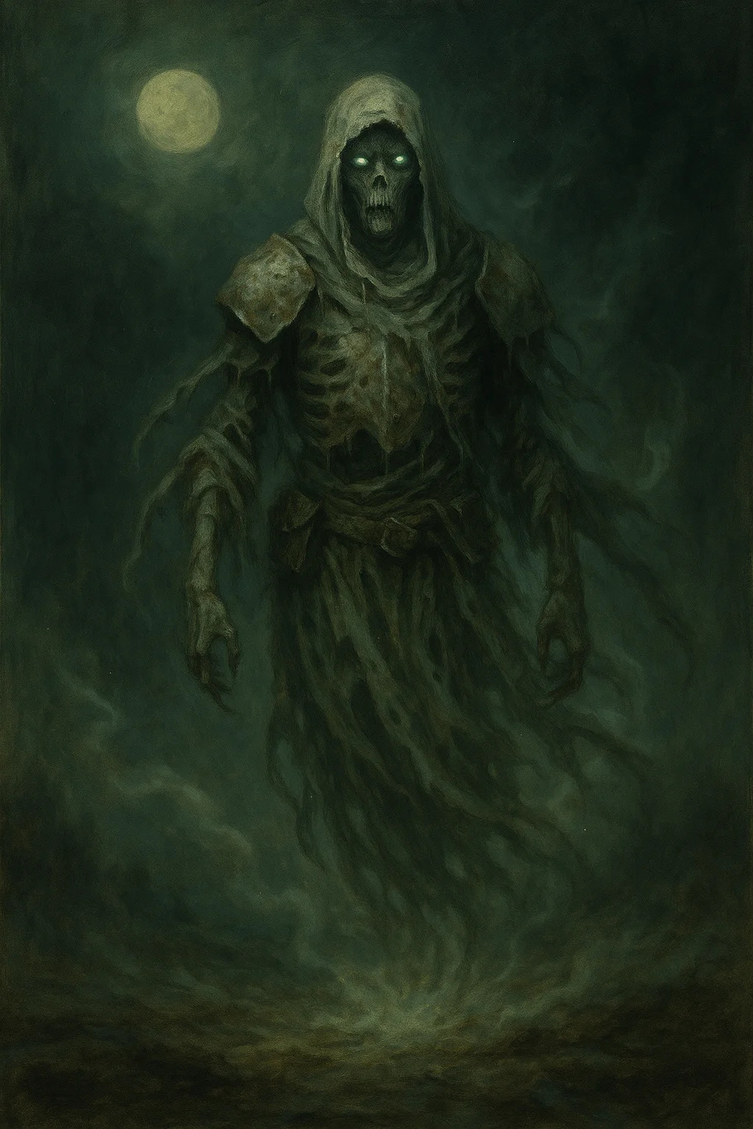

Medium undead, neutral evil

Armor Class 13

Hit Points 67 (9d8 + 27)

Speed 0 ft., fly 60 ft. (hover)

|  |  |  |  |  |  |
| --- | --- | --- | --- | --- | --- |
| STR | DEX | CON | INT | WIS | CHA |
| 6 (-2) | 16 (+3) | 16 (+3) | 12 (+1) | 14 (+2) | 15 (+2) |

Damage Resistances acid, cold, fire, lightning, thunder; bludgeoning, piercing, and slashing from nonmagical attacks

Damage Immunities necrotic, poison

Condition Immunities charmed, exhaustion, grappled, paralyzed, petrified, poisoned, prone, restrained

Senses darkvision 60 ft., passive Perception 12

Languages the languages it knew in life

Challenge 5 (1,800 XP)

Incorporeal Movement. The wraith can move through other creatures and objects as if they were difficult terrain. It takes 5 (1d10) force damage if it ends its turn inside an object.

Sunlight Sensitivity. While in sunlight, the wraith has disadvantage on attack rolls and Wisdom (Perception) checks that rely on sight.

Border-Bound. The wraith is bound to the Border region where it died. If forced outside the Border, it takes 10 (3d6) psychic damage at the start of each of its turns.

Echoes of War. When the wraith first appears, each creature within 30 feet hears a snippet of the battle where it died (screams, clashing steel, etc.). The wraith can speak one phrase from its final moments.

**ACTIONS**

Life Drain. Melee Weapon Attack: +6 to hit, reach 5 ft., one creature. Hit: 21 (4d8 + 3) necrotic damage. The target must succeed on a DC 14 Constitution saving throw or its hit point maximum is reduced by an amount equal to the damage taken. This reduction lasts until the target finishes a long rest. The target dies if this effect reduces its hit point maximum to 0.

Create Specter. The wraith targets a humanoid within 10 feet of it that died violently in the last minute. The target's spirit rises as a specter under the wraith's control. The wraith can have no more than three specters under its control at one time.

**LORE**

Border wraiths are the spirits of soldiers and civilians who died in the countless conflicts in the Border region. They're drawn to battles, feeding on death and violence. Some retain fragments of their former identities and may be laid to rest if their remains are properly buried.

**TACTICS**

- Ambush from walls/objects

- Target squishier party members

- Use Create Specter on fallen enemies

- Flee if seriously injured (unless enraged)

**CAMPAIGN USE**

Blood & Coin: Haunt battlefields and ruins, add horror element

Shattered Oaths: May have information about ancient battles or locations

---

## Contested Land Elemental

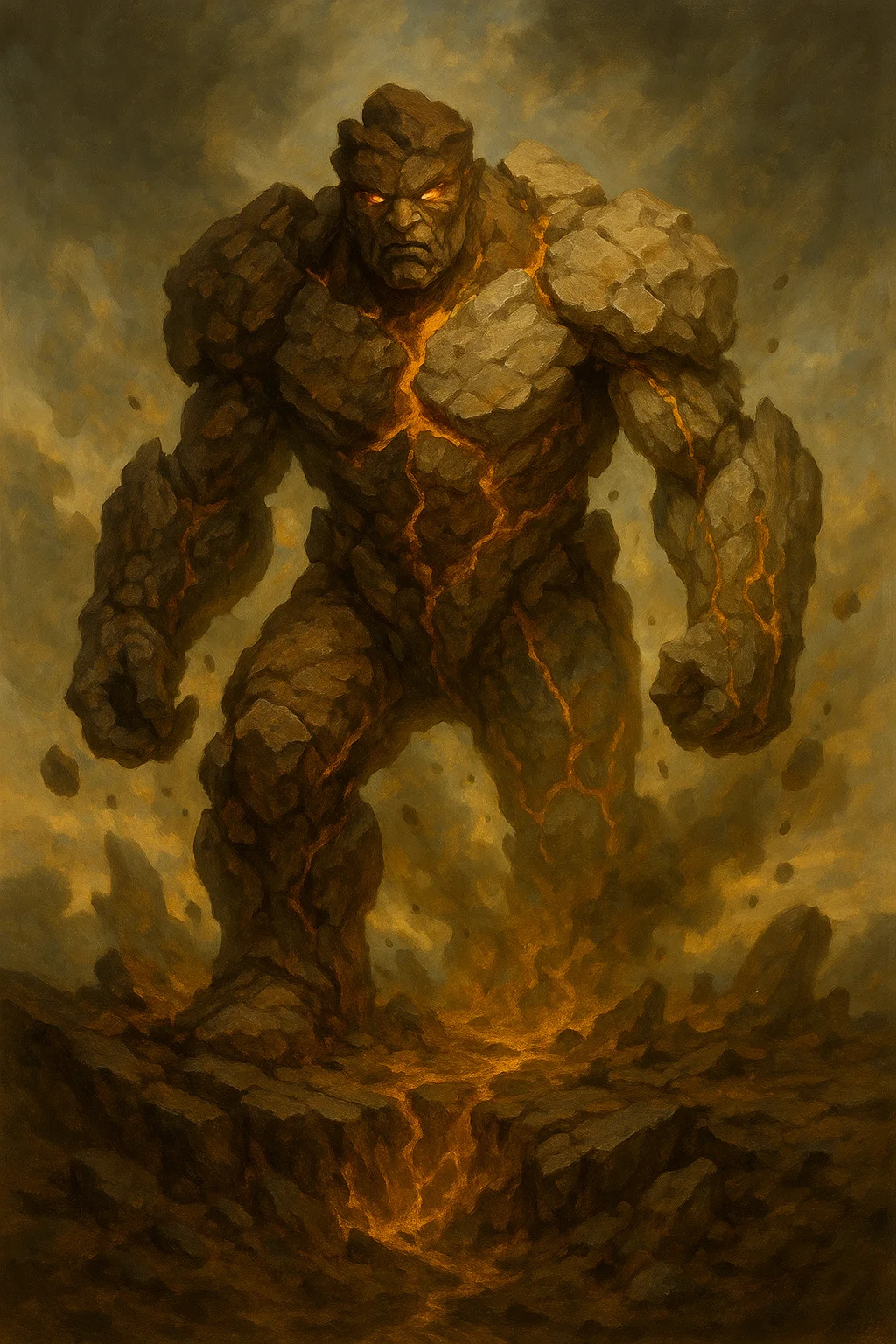

Large elemental, neutral

Armor Class 17 (natural armor)

Hit Points 126 (12d10 + 60)

Speed 30 ft., burrow 30 ft.

|  |  |  |  |  |  |
| --- | --- | --- | --- | --- | --- |
| STR | DEX | CON | INT | WIS | CHA |
| 20 (+5) | 8 (-1) | 20 (+5) | 5 (-3) | 10 (+0) | 5 (-3) |

Damage Vulnerabilities thunder

Damage Resistances bludgeoning, piercing, and slashing from nonmagical attacks

Damage Immunities poison

Condition Immunities exhaustion, paralyzed, petrified, poisoned, unconscious

Senses darkvision 60 ft., tremorsense 60 ft., passive Perception 10

Languages Terran

Challenge 6 (2,300 XP)

Earth Glide. The elemental can burrow through nonmagical, unworked earth and stone. While doing so, it doesn't disturb the material it moves through.

Siege Monster. The elemental deals double damage to objects and structures.

Mixed Form. The elemental's body contains earth from both Thaldros and Aethoria, making it unstable. When the elemental takes damage, roll 1d6. On a 5-6, it erupts, dealing 7 (2d6) bludgeoning damage to all creatures within 5 feet.

Territorial Fury. The elemental has advantage on attack rolls against creatures that have dealt damage to structures or the earth in the last minute.

**ACTIONS**

Multiattack. The elemental makes two slam attacks.

Slam. Melee Weapon Attack: +8 to hit, reach 10 ft., one target. Hit: 14 (2d8 + 5) bludgeoning damage.

Border Quake (Recharge 5-6). The elemental strikes the ground, creating a localized earthquake. Each creature on the ground within 20 feet must make a DC 15 Strength saving throw. On a failure, a creature takes 18 (4d8) bludgeoning damage and is knocked prone. On a success, the creature takes half damage and isn't knocked prone. Additionally, the ground in that area becomes difficult terrain until cleared.

**LORE**

These elementals form in the Border region, composed of earth from both nations. The constant conflict and bloodshed has made the land itself angry and unstable. They attack anyone who further damages the land but may ignore peaceful travelers.

**TACTICS**

- Emerge from underground (surprise)

- Focus on those damaging terrain

- Use Border Quake to knock down groups

- Retreat underground if badly hurt

**CAMPAIGN USE**

Both: Environmental hazard, obstacle to overcome, or potential ally if party respects the land

---

## Refugee Mob



Large swarm of Medium humanoids, any alignment

Armor Class 10

Hit Points 39 (6d10 + 6)

Speed 30 ft.

|  |  |  |  |  |  |
| --- | --- | --- | --- | --- | --- |
| STR | DEX | CON | INT | WIS | CHA |
| 10 (+0) | 10 (+0) | 12 (+1) | 10 (+0) | 10 (+0) | 8 (-1) |

Condition Immunities charmed, frightened, grappled, paralyzed, petrified, prone, restrained, stunned

Senses passive Perception 10

Languages Common

Challenge 1 (200 XP)

Swarm. The mob can occupy another creature's space and vice versa, and the mob can move through any opening large enough for a Medium humanoid. The mob can't regain hit points or gain temporary hit points.

Desperate Horde. The mob has advantage on attack rolls if it has half its hit points or more.

Panicked. The mob has disadvantage on Wisdom saving throws while below half hit points.

**ACTIONS**

Mob Violence. Melee Weapon Attack: +2 to hit, reach 0 ft., one creature in the swarm's space. Hit: 14 (4d6) bludgeoning damage, or 7 (2d6) bludgeoning damage if the swarm has half its hit points or fewer.

**REACTIONS**

Stampede. When the mob takes damage from an area effect, it can move up to its speed away from the source of danger. This movement doesn't provoke opportunity attacks.

**LORE**

Desperate refugees sometimes form angry mobs, driven by fear, hunger, or manipulation. They're not eviljust desperate people in terrible circumstances. Most will flee or surrender if given the opportunity.

**TACTICS**

- Overwhelm through numbers

- Target obvious threats

- Flee if leaders fall or hope is offered

- Can be calmed with Persuasion (DC 15)

**CAMPAIGN USE**

Blood & Coin: Moral dilemmathey're a threat but also victims

Shattered Oaths: Potential recruits if handled with compassion

---

## Scavenger Ghoul

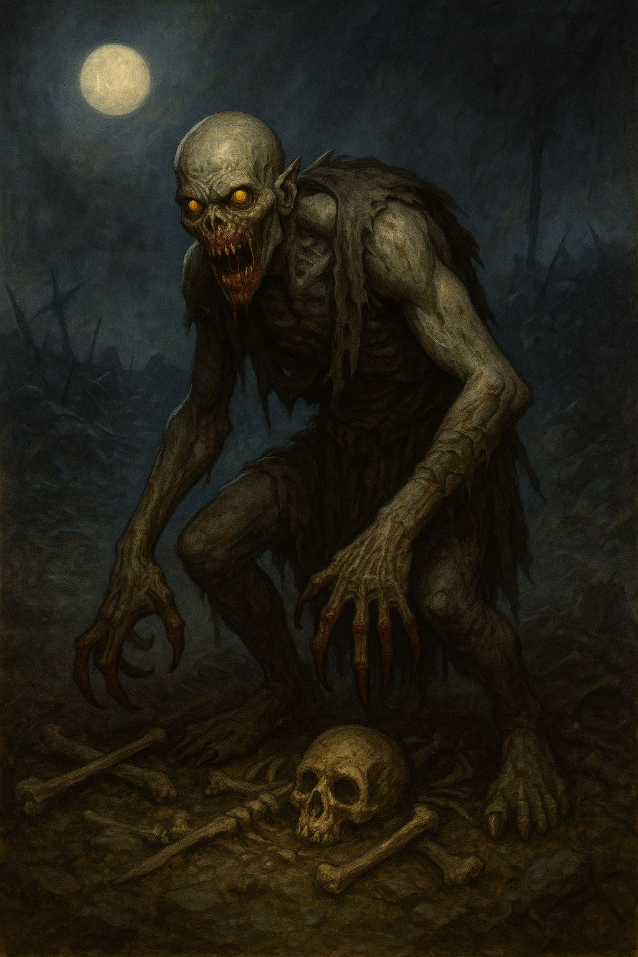

Medium undead, chaotic evil

Armor Class 12

Hit Points 22 (5d8)

Speed 30 ft.

|  |  |  |  |  |  |
| --- | --- | --- | --- | --- | --- |
| STR | DEX | CON | INT | WIS | CHA |
| 13 (+1) | 15 (+2) | 10 (+0) | 7 (-2) | 10 (+0) | 6 (-2) |

Damage Immunities poison

Condition Immunities charmed, exhaustion, poisoned

Senses darkvision 60 ft., passive Perception 10

Languages Common

Challenge 1 (200 XP)

Battlefield Scavenger. The ghoul has advantage on Wisdom (Perception) checks to find corpses or wounded creatures.

Pack Tactics. The ghoul has advantage on attack rolls against a creature if at least one of the ghoul's allies is within 5 feet of the creature and the ally isn't incapacitated.

**ACTIONS**

Bite. Melee Weapon Attack: +4 to hit, reach 5 ft., one creature. Hit: 9 (2d6 + 2) piercing damage.

Claws. Melee Weapon Attack: +4 to hit, reach 5 ft., one target. Hit: 7 (2d4 + 2) slashing damage. If the target is a creature other than an elf or undead, it must succeed on a DC 10 Constitution saving throw or be paralyzed for 1 minute. The target can repeat the saving throw at the end of each of its turns, ending the effect on itself on a success.

Corpse Feast (Recharge 5-6). If the ghoul is adjacent to a corpse or unconscious creature, it can spend its action feeding. It regains 10 (3d6) hit points.

**LORE**

The Border's constant violence creates ample food for ghouls. These undead scavengers lurk near battlefields and ambush sites, waiting for fresh corpsesor making their own.

**TACTICS**

- Hunt in packs (2-8 ghouls)

- Target wounded enemies

- Use paralysis on dangerous foes

- Feast mid-combat if possible

**CAMPAIGN USE**

Both: Common undead encounter in Border region

---

## Territorial Drake

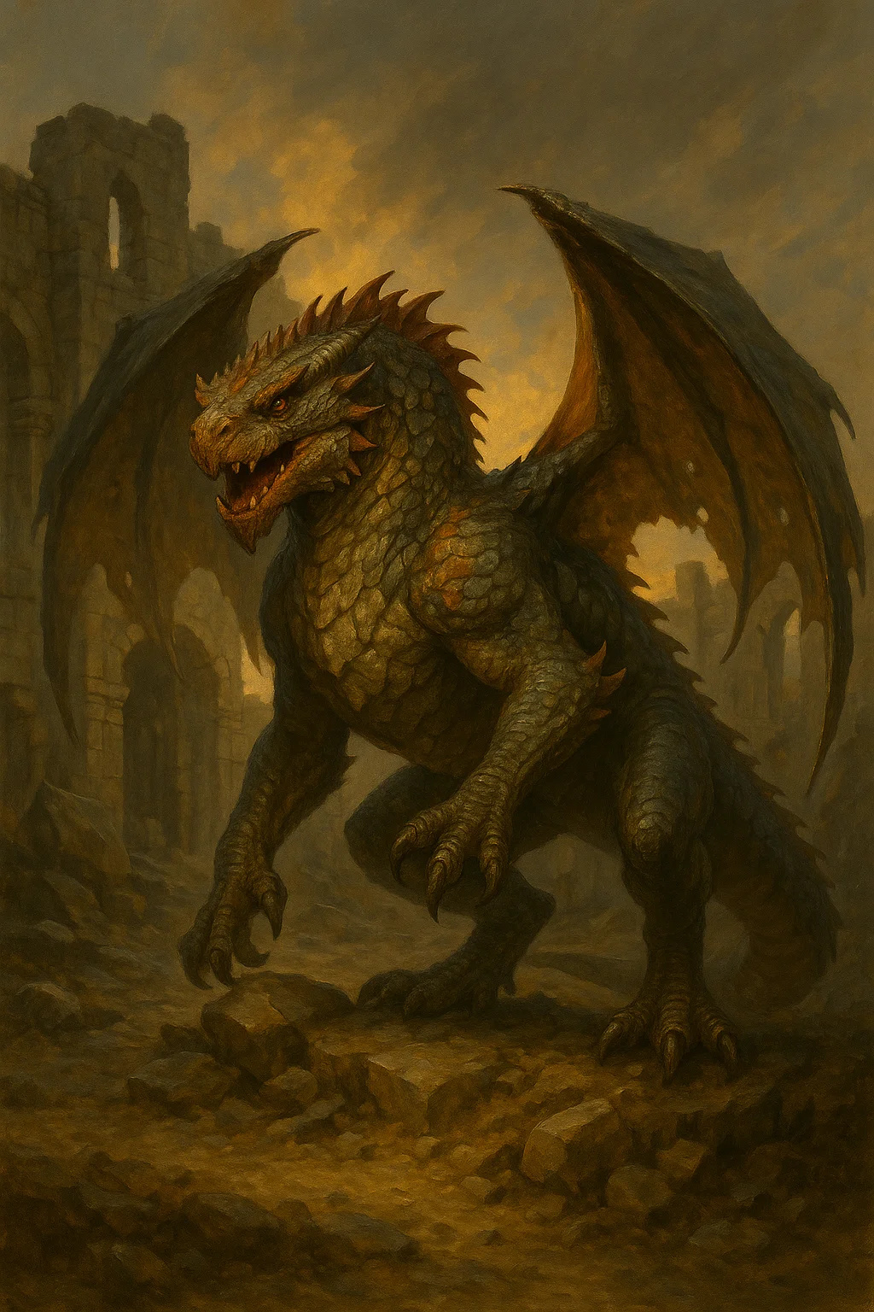

Large dragon, unaligned

Armor Class 14 (natural armor)

Hit Points 52 (7d10 + 14)

Speed 30 ft., climb 30 ft.

|  |  |  |  |  |  |
| --- | --- | --- | --- | --- | --- |
| STR | DEX | CON | INT | WIS | CHA |
| 16 (+3) | 11 (+0) | 14 (+2) | 4 (-3) | 10 (+0) | 7 (-2) |

Skills Perception +2, Stealth +2

Senses darkvision 60 ft., passive Perception 12

Languages understands Draconic but can't speak

Challenge 2 (450 XP)

Border Camouflage. The drake has advantage on Dexterity (Stealth) checks in rocky or ruined terrain.

Pack Tactics. The drake has advantage on attack rolls against a creature if at least one of the drake's allies is within 5 feet of the creature and the ally isn't incapacitated.

**ACTIONS**

Multiattack. The drake makes one bite attack and one tail attack.

Bite. Melee Weapon Attack: +5 to hit, reach 5 ft., one target. Hit: 7 (1d8 + 3) piercing damage.

Tail. Melee Weapon Attack: +5 to hit, reach 5 ft., one target. Hit: 6 (1d6 + 3) bludgeoning damage, and the target must succeed on a DC 13 Strength saving throw or be knocked prone.

Warning Roar (Recharge 5-6). The drake roars, alerting other drakes in a 1-mile radius. Allied drakes within 60 feet gain advantage on their next attack roll.

**LORE**

These drakes have claimed territories in the Border's ruins and caves. They're aggressive toward intruders but intelligent enough to recognize when they're outmatched. Some mercenary bands have trained them as mounts or guards.

**TACTICS**

- Ambush from high ground

- Work in pairs if possible

- Use tail to knock down enemies

- Flee to lair if seriously wounded

**CAMPAIGN USE**

Blood & Coin: Encountered in ruins, potential to be trained/tamed

Shattered Oaths: Guard important locations or paths

---

## War Beast

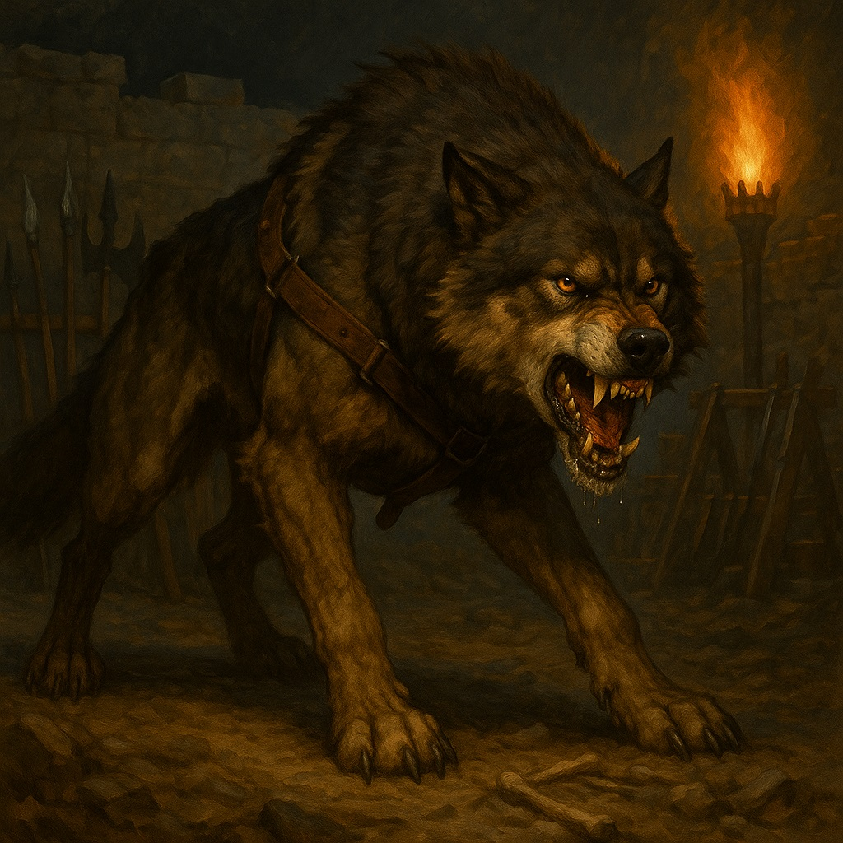

Large beast, unaligned

Armor Class 14 (natural armor)

Hit Points 45 (6d10 + 12)

Speed 50 ft.

|  |  |  |  |  |  |
| --- | --- | --- | --- | --- | --- |
| STR | DEX | CON | INT | WIS | CHA |
| 17 (+3) | 15 (+2) | 15 (+2) | 3 (-4) | 12 (+1) | 7 (-2) |

Skills Perception +3, Stealth +4

Senses passive Perception 13

Languages

Challenge 3 (700 XP)

Keen Hearing and Smell. The beast has advantage on Wisdom (Perception) checks that rely on hearing or smell.

Pack Tactics. The beast has advantage on attack rolls against a creature if at least one of the beast's allies is within 5 feet of the creature and the ally isn't incapacitated.

Trained Killer. The beast was trained for war. It has advantage on attack rolls against frightened creatures.

**ACTIONS**

Bite. Melee Weapon Attack: +5 to hit, reach 5 ft., one target. Hit: 10 (2d6 + 3) piercing damage. If the target is a creature, it must succeed on a DC 13 Strength saving throw or be knocked prone.

Pounce. If the beast moves at least 20 feet straight toward a creature and then hits it with a bite attack on the same turn, that target must succeed on a DC 13 Strength saving throw or be knocked prone. If the target is prone, the beast can make one bite attack against it as a bonus action.

Intimidating Howl (Recharge 5-6). The beast howls. Each enemy within 30 feet that can hear it must succeed on a DC 11 Wisdom saving throw or become frightened for 1 minute. A frightened creature can repeat the save at the end of each of its turns, ending the effect on a success.

**LORE**

Both armies use war beastsmassive wolves, war dogs, or other predators bred and trained for combat. Some have escaped and gone feral in the Border, becoming apex predators.

**TACTICS**

- Hunt in packs (2-5 beasts)

- Use Pounce to knock down targets

- Focus on frightened enemies

- Protect handlers if trained

**CAMPAIGN USE**

Both: Used by military forces, encountered wild in Border

---

## Haunted Battlefield

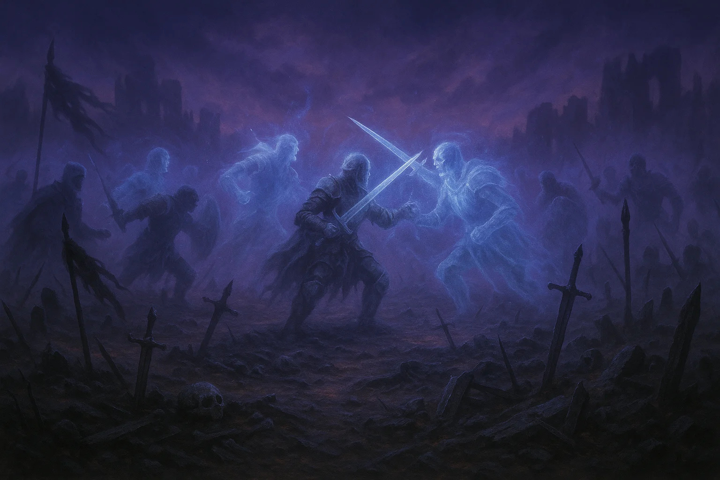

Gargantuan hazard/swarm, chaotic neutral

Armor Class 15

Hit Points 150 (12d20 + 24)

Speed 0 ft.

|  |  |  |  |  |  |
| --- | --- | --- | --- | --- | --- |
| STR | DEX | CON | INT | WIS | CHA |
| 1 (-5) | 20 (+5) | 14 (+2) | 10 (+0) | 14 (+2) | 16 (+3) |

Damage Resistances bludgeoning, piercing, slashing

Damage Immunities poison, psychic

Condition Immunities all

Senses blindsight 120 ft., passive Perception 12

Languages understands all languages but can't speak

Challenge 7 (2,900 XP)

Immobile Hazard. The battlefield doesn't move. It exists as a 120-foot radius area of lingering death magic and tortured spirits.

Echo of Battle. Any creature that enters the area for the first time on a turn or starts its turn there must make a DC 15 Wisdom saving throw or take 14 (4d6) psychic damage and have disadvantage on attack rolls until the start of its next turn as ghostly weapons strike and spectral screams assault it.

Restless Dead. At the start of each round, 1d4 spectral soldiers (use specter statblock) manifest within the area. They attack the nearest living creatures and disappear after 1 minute or when reduced to 0 hit points.

Consecration Vulnerable. If a cleric or paladin spends 10 minutes performing funeral rites within the area, the battlefield's power is suppressed for 24 hours in a 30-foot radius around the ritual site.

**ACTIONS**

The battlefield doesn't take actions in the traditional senseits effects are constant.

Phantom Army (Recharge 5-6). At initiative count 20, the battlefield can summon a phantom army. All creatures in the area see ghostly soldiers fighting and dying around them. Each creature must make a DC 15 Wisdom saving throw. On a failure, a creature takes 22 (4d10) psychic damage and is frightened until the end of its next turn. On a success, the creature takes half damage and isn't frightened.

**LORE**

Some battlefields in the Border have seen so much death that the land itself became haunted. These cursed areas trap the spirits of fallen soldiers, endlessly reenacting their final battle. The only way to permanently end a haunted battlefield is to consecrate it with proper funeral ritesa dangerous undertaking.

**TACTICS**

This is an environmental hazard more than a traditional enemy. DMs should:

- Describe the horror and chaos

- Track who enters the area

- Roll for spectral spawns

- Allow creative solutions (not just combat)

**CAMPAIGN USE**

Blood & Coin: Major obstacle, quest to consecrate site

Shattered Oaths: Prophecy location, must be cleansed for important ritual

---

**END OF BORDER CREATURES**

10 unique monsters for the contested lands between nations

Next: Thaldros Military units...

# Thaldros Military

The disciplined might of Thaldros, from conscripts to champions

## Thaldros Conscript

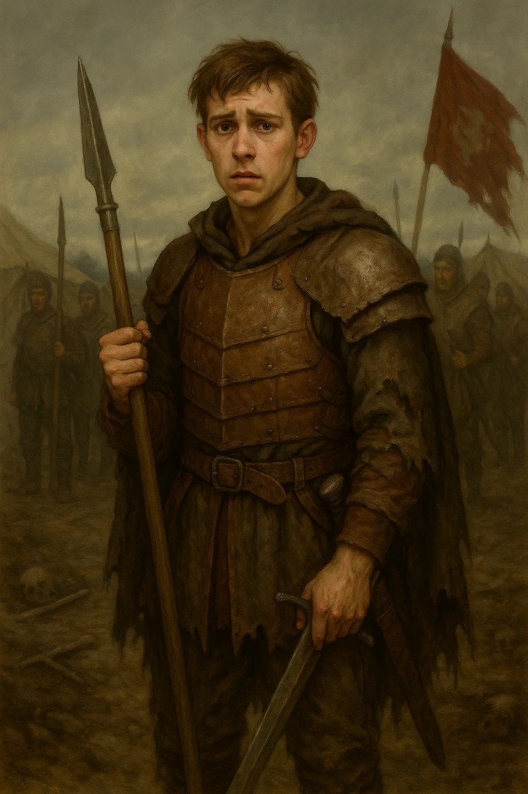

Medium humanoid (any race), lawful neutral

Armor Class 10 (no armor)

Hit Points 4 (1d8)

Speed 30 ft.

|  |  |  |  |  |  |
| --- | --- | --- | --- | --- | --- |
| STR | DEX | CON | INT | WIS | CHA |
| 10 (+0) | 10 (+0) | 10 (+0) | 9 (-1) | 10 (+0) | 9 (-1) |

Senses passive Perception 10

Languages Common

Challenge 1/8 (25 XP)

Poorly Trained. The conscript has disadvantage on attack rolls if an ally within 5 feet is reduced to 0 hit points since the end of the conscript's last turn.

Reluctant Fighter. The conscript has disadvantage on death saving throws.

**ACTIONS**

Spear. Melee or Ranged Weapon Attack: +2 to hit, reach 5 ft. or range 20/60 ft., one target. Hit: 3 (1d6) piercing damage, or 4 (1d8) piercing damage if used with two hands for a melee attack.

**LORE**

Most of Thaldros's army consists of conscripted farmers, laborers, and urban poor. They're given minimal training and thrown into battle. Many desert if given the chance. Conscripts often have families back home they're fighting to return to.

**TACTICS**

- Fight in large groups (5-20)

- Flee if leaders fall

- May surrender if treated well

- Protect each other (poorly)

**CAMPAIGN USE**

Blood & Coin: Moral questionthey're enemies but also victims

Shattered Oaths: Perfect target for compassion/recruitment

---

## Thaldros Soldier

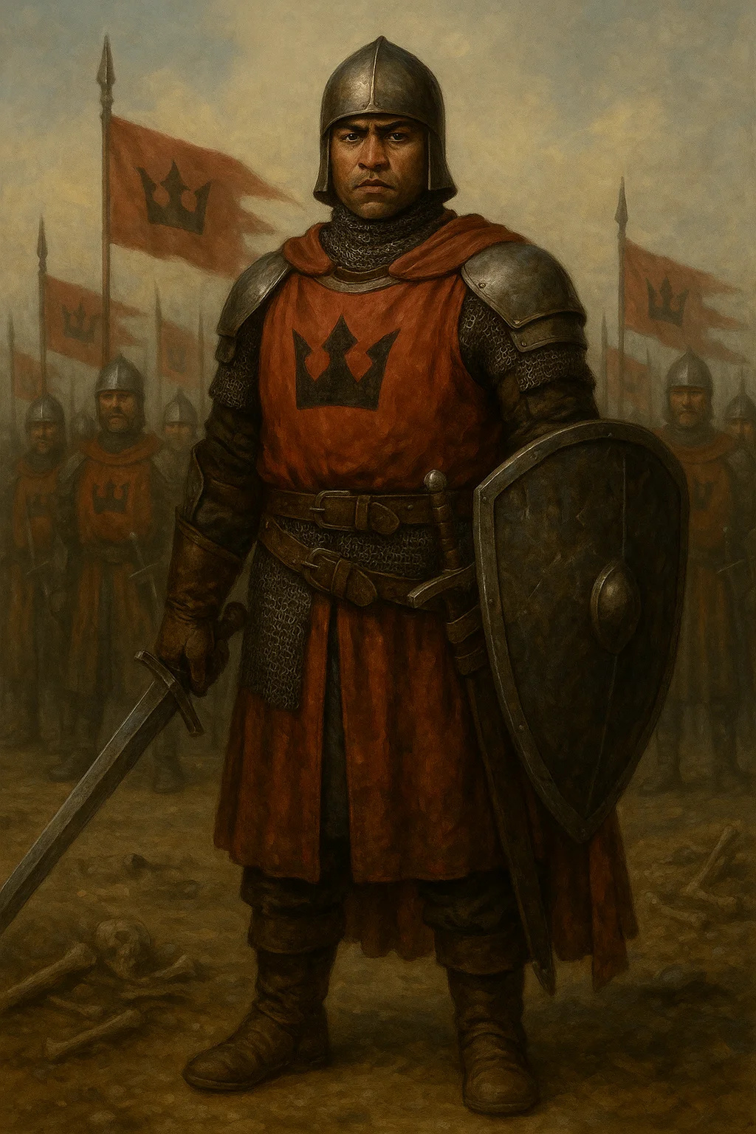

Medium humanoid (any race), lawful neutral

Armor Class 16 (chain shirt, shield)

Hit Points 11 (2d8 + 2)

Speed 30 ft.

|  |  |  |  |  |  |
| --- | --- | --- | --- | --- | --- |
| STR | DEX | CON | INT | WIS | CHA |
| 13 (+1) | 12 (+1) | 12 (+1) | 10 (+0) | 11 (+0) | 10 (+0) |

Skills Athletics +3, Perception +2

Senses passive Perception 12

Languages Common

Challenge 1/2 (100 XP)

Formation Fighter. The soldier has advantage on saving throws against being frightened while within 5 feet of an ally.

Imperial Discipline. The soldier can reroll a failed saving throw once per short rest.

**ACTIONS**

Longsword. Melee Weapon Attack: +3 to hit, reach 5 ft., one target. Hit: 5 (1d8 + 1) slashing damage, or 6 (1d10 + 1) slashing damage if used with two hands.

Crossbow. Ranged Weapon Attack: +3 to hit, range 80/320 ft., one target. Hit: 5 (1d8 + 1) piercing damage.

**REACTIONS**

Shield Wall. When an ally within 5 feet is hit by an attack, the soldier can grant them +2 to AC against that attack.

**LORE**

Professional soldiers of Thaldros are disciplined, well-equipped, and indoctrinated into loyalty to the empire. Unlike conscripts, they're career soldiers who believe in Thaldros's vision of order and stability.

**TACTICS**

- Fight in formation (shield wall)

- Support allies

- Follow orders strictly

- Retreat only when commanded

**CAMPAIGN USE**

Both: Standard enemy troops, garrison guards, patrol units

---

## Iron Legion Enforcer

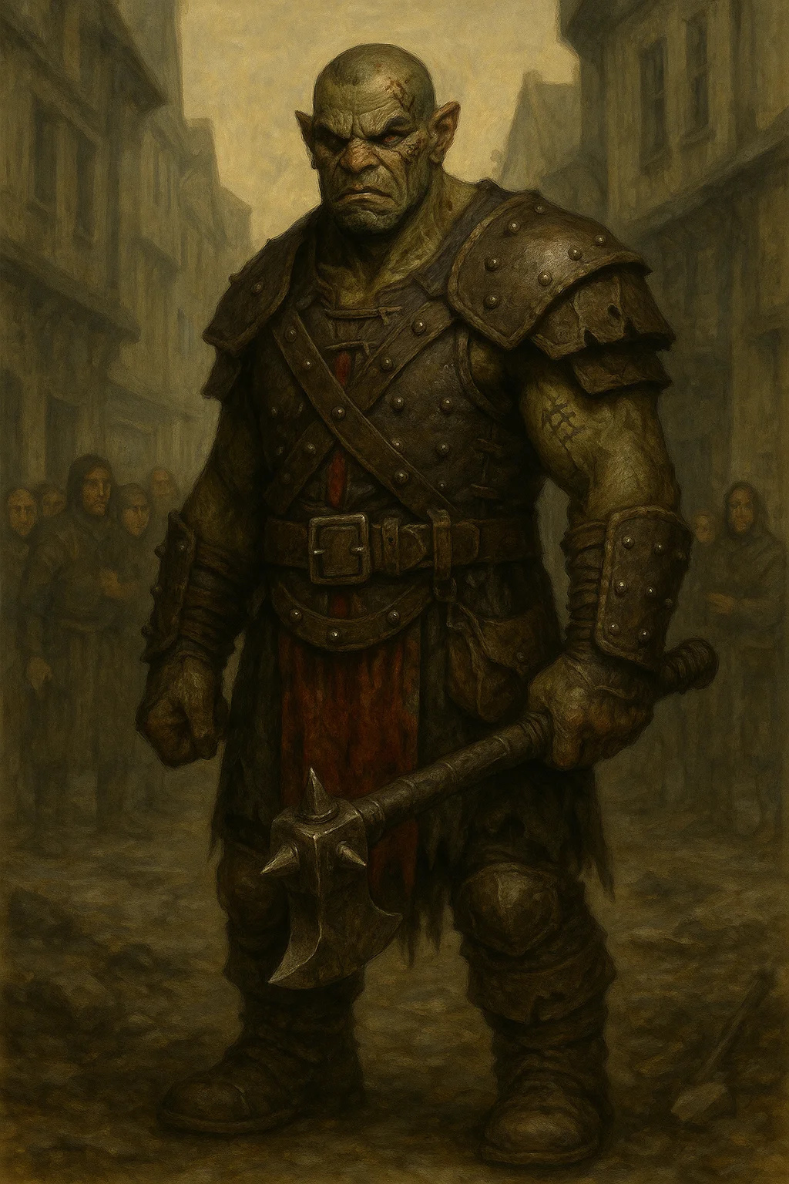

Medium humanoid (any race), lawful evil

Armor Class 13 (leather armor)

Hit Points 32 (5d8 + 10)

Speed 30 ft.

|  |  |  |  |  |  |
| --- | --- | --- | --- | --- | --- |
| STR | DEX | CON | INT | WIS | CHA |
| 15 (+2) | 11 (+0) | 14 (+2) | 10 (+0) | 12 (+1) | 14 (+2) |

Skills Intimidation +4, Perception +3

Senses passive Perception 13

Languages Common

Challenge 2 (450 XP)

Brutal. The enforcer's melee weapon attacks deal one extra die of damage (included in the attacks).

Pack Tactics. The enforcer has advantage on attack rolls against a creature if at least one of the enforcer's allies is within 5 feet of the creature and the ally isn't incapacitated.

**ACTIONS**

Multiattack. The enforcer makes two attacks with its mace.

Mace. Melee Weapon Attack: +4 to hit, reach 5 ft., one target. Hit: 9 (2d6 + 2) bludgeoning damage.

Intimidate. The enforcer targets one creature it can see within 30 feet. The target must succeed on a DC 12 Wisdom saving throw or become frightened for 1 minute. A frightened target can repeat the save at the end of each of its turns, ending the effect on a success.

**LORE**

The Iron Legion are Thaldros's internal security forcebrutal enforcers who maintain order through fear and violence. They're called when the regular army isn't cruel enough. Hated by commoners and feared even by soldiers.

**TACTICS**

- Use intimidation liberally

- Beat down resisters

- Work in pairs or groups

- Make examples of defiers

**CAMPAIGN USE**

Blood & Coin: May hire mercenaries for dirty work

Shattered Oaths: Perfect villainscruel oppressors

## Royal Guard Elite

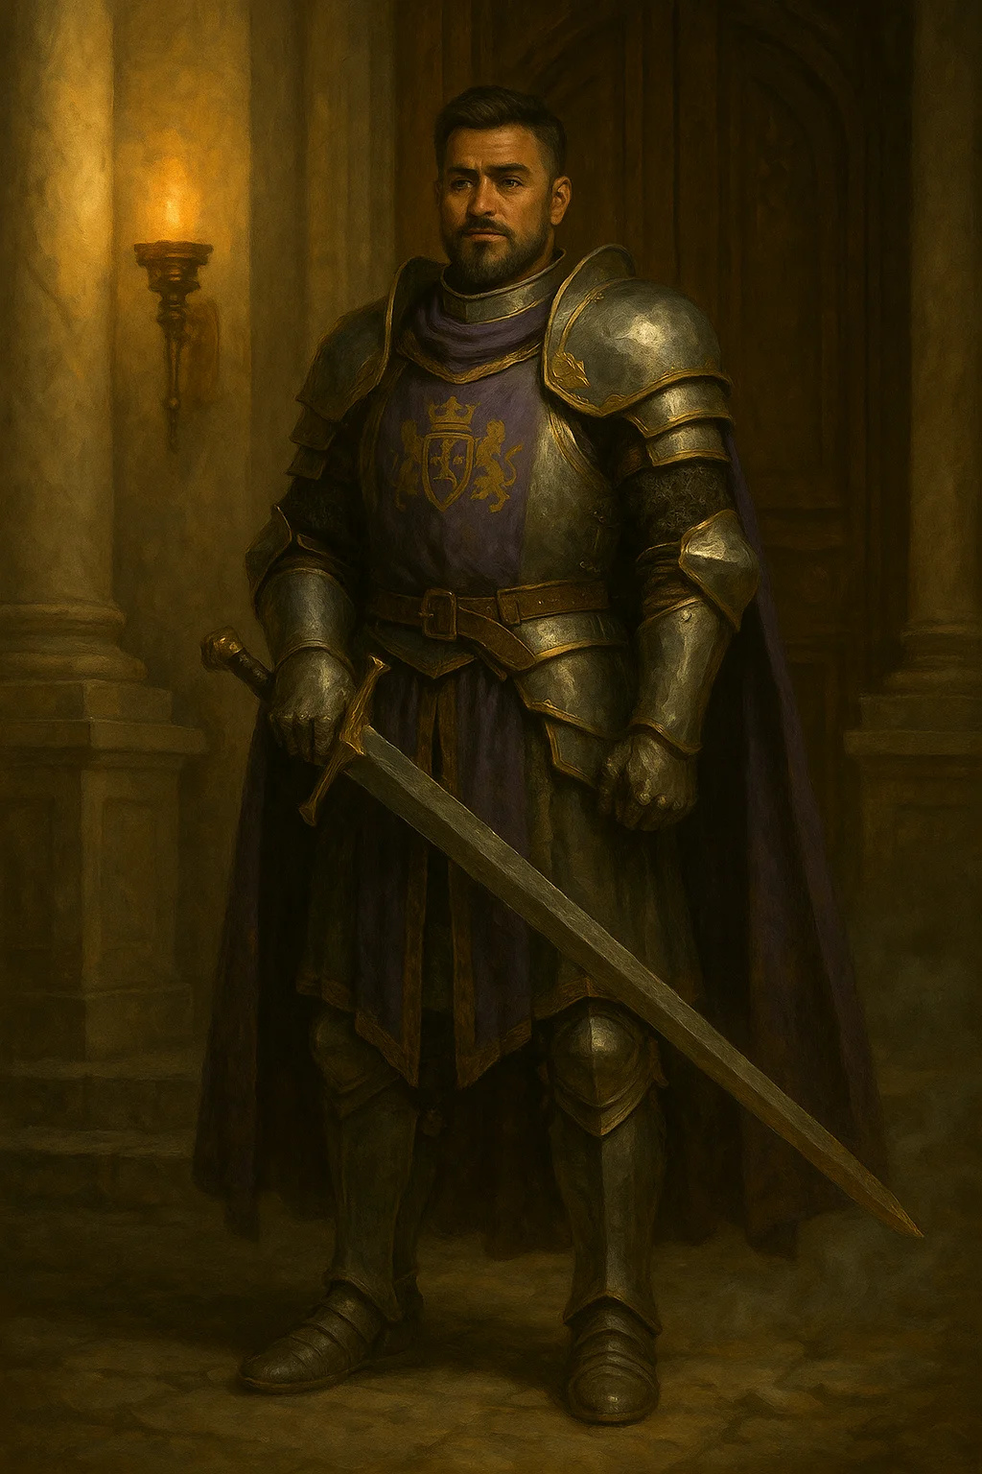

Medium humanoid (any race), lawful neutral

Armor Class 18 (plate armor)

Hit Points 52 (8d8 + 16)

Speed 30 ft.

|  |  |  |  |  |  |
| --- | --- | --- | --- | --- | --- |
| STR | DEX | CON | INT | WIS | CHA |
| 16 (+3) | 11 (+0) | 14 (+2) | 11 (+0) | 11 (+0) | 15 (+2) |

Saving Throws Constitution +4, Wisdom +2

Skills Athletics +5, Intimidation +4, Perception +2

Senses passive Perception 12

Languages Common

Challenge 5 (1,800 XP)

Brave. The guard has advantage on saving throws against being frightened.

Royal Authority. Allied creatures within 10 feet gain advantage on saving throws against being frightened.

**ACTIONS**

Multiattack. The guard makes two greatsword attacks.

Greatsword. Melee Weapon Attack: +5 to hit, reach 5 ft., one target. Hit: 10 (2d6 + 3) slashing damage.

Heavy Crossbow. Ranged Weapon Attack: +2 to hit, range 100/400 ft., one target. Hit: 5 (1d10) piercing damage.

Leadership (Recharges after a Short or Long Rest). For 1 minute, the guard can utter a command or warning whenever a nonhostile creature within 30 feet makes an attack roll or saving throw. That creature can add a d4 to its roll. A creature can benefit from only one Leadership die at a time.

**REACTIONS**

Parry. The guard adds 2 to their AC against one melee attack that would hit them.

**LORE**

The Royal Guard are the elite soldiers of Thaldros, sworn to protect nobility and enforce the king's will. They're highly trained, well-equipped, and fanatically loyal. Unlike Iron Legion thugs, Royal Guards are respected even by their enemies.

**TACTICS**

- Protect VIPs at all costs

- Use Leadership to buff allies

- Fight honorably but effectively

- Coordinate attacks

**CAMPAIGN USE**

Both: Bodyguards for important targets, elite enemies, potential honorable foes

---

## State Inquisitor

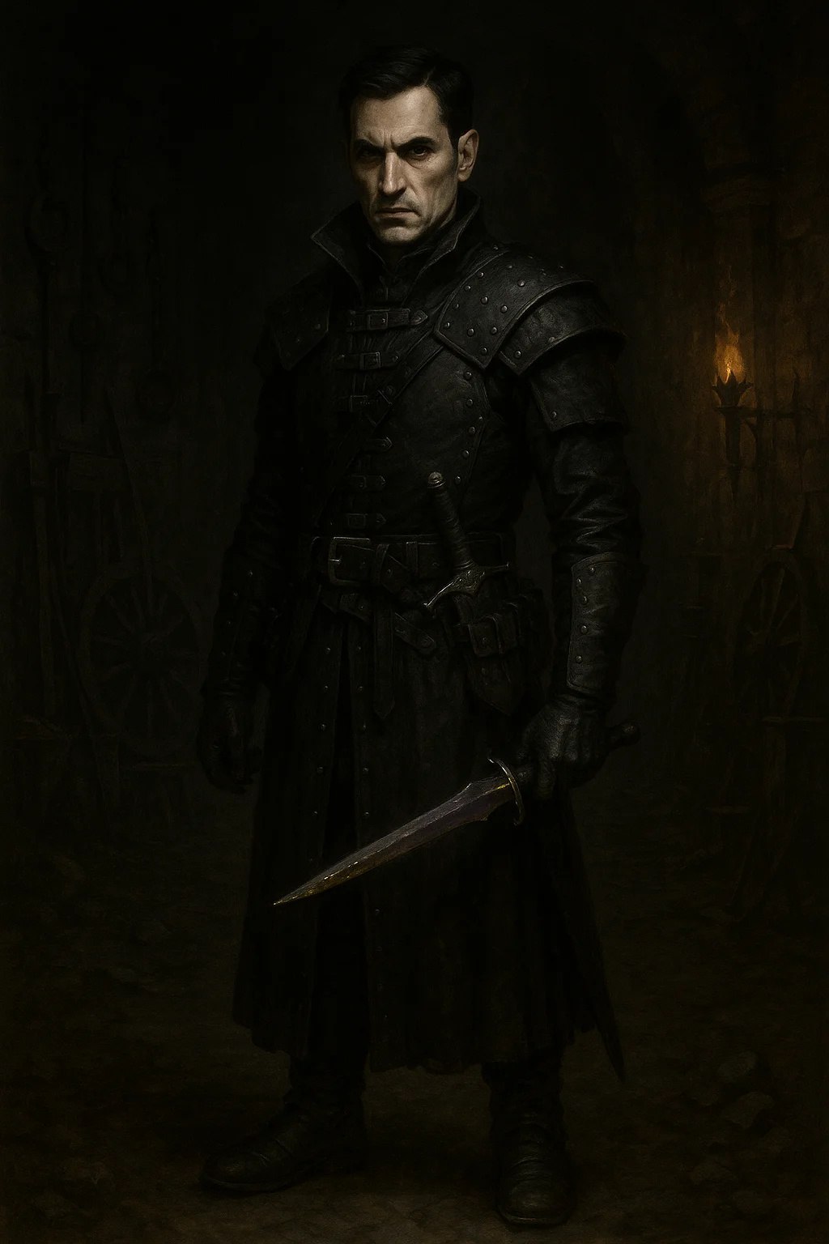

Medium humanoid (any race), lawful evil

Armor Class 15 (studded leather)

Hit Points 78 (12d8 + 24)

Speed 30 ft.

|  |  |  |  |  |  |
| --- | --- | --- | --- | --- | --- |
| STR | DEX | CON | INT | WIS | CHA |
| 11 (+0) | 16 (+3) | 14 (+2) | 16 (+3) | 14 (+2) | 16 (+3) |

Saving Throws Dexterity +6, Intelligence +6, Wisdom +5

Skills Deception +6, Insight +5, Investigation +9, Perception +5, Stealth +6

Senses passive Perception 15

Languages Common, plus three others

Challenge 6 (2,300 XP)

Cunning Action. On each turn, the inquisitor can use a bonus action to Dash, Disengage, or Hide.

Evasion. If the inquisitor is subjected to an effect that allows them to make a Dexterity saving throw to take only half damage, they take no damage on a success and half damage on a failure.

Sneak Attack (1/Turn). The inquisitor deals an extra 14 (4d6) damage when hitting with a weapon attack and has advantage on the attack roll, or when the target is within 5 feet of an ally.

Information Network. The inquisitor can spend 1 hour in a settlement to learn one piece of useful information about a specific person or event.

**ACTIONS**

Multiattack. The inquisitor makes two shortsword attacks.

Shortsword. Melee Weapon Attack: +6 to hit, reach 5 ft., one target. Hit: 6 (1d6 + 3) piercing damage, plus poison (see Poisoned Blade).

Hand Crossbow. Ranged Weapon Attack: +6 to hit, range 30/120 ft., one target. Hit: 6 (1d6 + 3) piercing damage, plus poison (see Poisoned Blade).

Poisoned Blade. The inquisitor's weapon is coated in a special poison. The target must make a DC 14 Constitution saving throw, taking 10 (3d6) poison damage on a failed save, or half as much on a success.

Interrogate (3/Day). The inquisitor targets one creature within 30 feet that can hear them. The target must make a DC 14 Wisdom saving throw. On a failure, the target is compelled to answer one question truthfully. This is a magical compulsion effect.

**REACTIONS**

Uncanny Dodge. When an attacker the inquisitor can see hits them with an attack, they can halve the attack's damage.

**LORE**

State Inquisitors are Thaldros's secret policespies, assassins, and interrogators who root out dissent and eliminate threats to the empire. They're feared throughout Tirvandor and operate with complete authority.

**TACTICS**

- Gather intelligence first

- Poisoned weapons on priority targets

- Use Interrogate to extract info

- Escape if discovered

**CAMPAIGN USE**

Blood & Coin: Quest givers (if players work for Thaldros) or dangerous enemies

Shattered Oaths: Major antagonists, hunter of heroes

---

## War Mage Of Thaldros

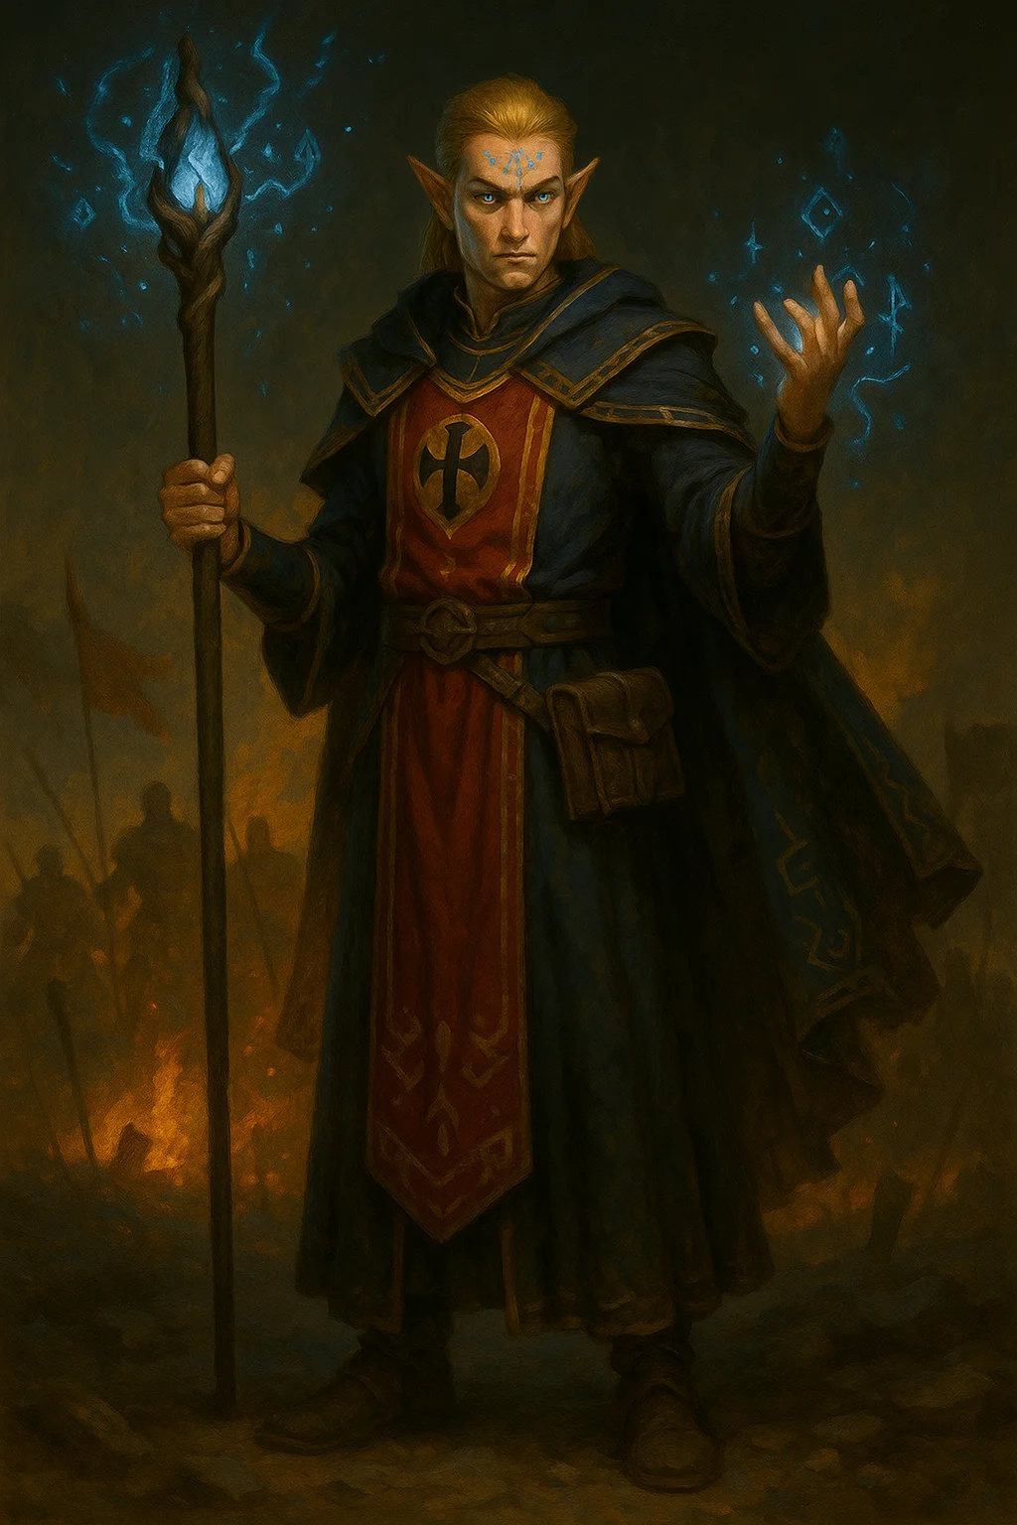

Medium humanoid (any race), lawful neutral

Armor Class 12 (15 with mage armor)

Hit Points 66 (12d8 + 12)

Speed 30 ft.

|  |  |  |  |  |  |
| --- | --- | --- | --- | --- | --- |
| STR | DEX | CON | INT | WIS | CHA |
| 9 (-1) | 14 (+2) | 12 (+1) | 17 (+3) | 12 (+1) | 11 (+0) |

Saving Throws Intelligence +6, Wisdom +4

Skills Arcana +6, History +6

Senses passive Perception 11

Languages Common, plus three others

Challenge 7 (2,900 XP)

Spellcasting. The mage is a 9th-level spellcaster. Spellcasting ability is Intelligence (spell save DC 14, +6 to hit with spell attacks). The mage has the following wizard spells prepared:

Cantrips: fire bolt, light, mage hand, prestidigitation

1st level (4 slots): detect magic, mage armor, magic missile, shield

2nd level (3 slots): misty step, scorching ray, suggestion

3rd level (3 slots): counterspell, fireball, lightning bolt

4th level (3 slots): greater invisibility, ice storm

5th level (1 slot): cone of cold, wall of force

War Caster. The mage has advantage on Constitution saving throws to maintain concentration on spells. When a hostile creature's movement provokes an opportunity attack, the mage can cast a spell at the creature rather than making an opportunity attack.

**ACTIONS**

Quarterstaff. Melee Weapon Attack: +2 to hit, reach 5 ft., one target. Hit: 2 (1d6 - 1) bludgeoning damage, or 3 (1d8 - 1) if used with two hands.

**LORE**

Thaldros trains battle mages specifically for military operations. Unlike academic wizards, War Mages focus on destructive evocation magic and battlefield control. They're attached to military units and respected (and feared) by soldiers.

**TACTICS**

- Stay behind front line

- Use fireball and lightning bolt on groups

- Counterspell enemy magic

- Misty step away from danger

- Conserve 5th level slot for emergency

**CAMPAIGN USE**

Both: Dangerous enemies, artillery support for military encounters

---

## Siege Golem

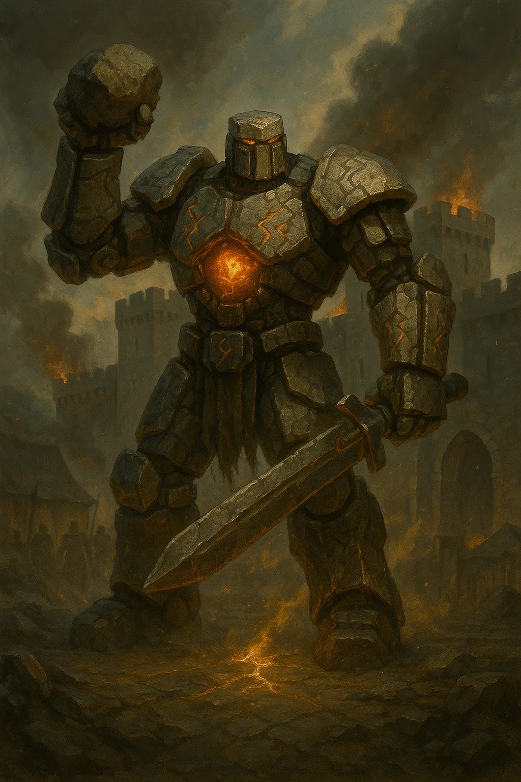

Large construct, unaligned

Armor Class 17 (natural armor)

Hit Points 157 (15d10 + 75)

Speed 20 ft.

|  |  |  |  |  |  |
| --- | --- | --- | --- | --- | --- |
| STR | DEX | CON | INT | WIS | CHA |
| 22 (+6) | 9 (-1) | 20 (+5) | 3 (-4) | 11 (+0) | 1 (-5) |

Damage Immunities poison, psychic; bludgeoning, piercing, and slashing from nonmagical attacks not made with adamantine weapons

Condition Immunities charmed, exhaustion, frightened, paralyzed, petrified, poisoned

Senses darkvision 120 ft., passive Perception 10

Languages understands the languages of its creator but can't speak

Challenge 8 (3,900 XP)

Immutable Form. The golem is immune to any spell or effect that would alter its form.

Magic Resistance. The golem has advantage on saving throws against spells and other magical effects.

Siege Monster. The golem deals double damage to objects and structures.

Military Programming. The golem follows tactical commands perfectly and can execute complex battle plans.

**ACTIONS**

Multiattack. The golem makes two slam attacks.

Slam. Melee Weapon Attack: +10 to hit, reach 5 ft., one target. Hit: 19 (3d8 + 6) bludgeoning damage.

Boulder Launch (Recharge 5-6). Ranged Weapon Attack: +10 to hit, range 60/240 ft., one target. Hit: 32 (4d12 + 6) bludgeoning damage. If the target is a structure, it takes double damage.

Siege Mode (1/Day). For 1 minute, the golem becomes rooted in place (speed 0) but gains advantage on attack rolls and its attacks deal maximum damage to structures.

**LORE**

Thaldros's military mages have created these massive constructs for sieges and large battles. They're slow but nearly unstoppable, designed to break through fortifications and scatter enemy formations.

**TACTICS**

- Advance slowly and steadily

- Focus on structures in Siege Mode

- Target clustered enemies with Boulder Launch

- Ignore distractions

**CAMPAIGN USE**

Both: Major set-piece battle, siege defense/assault

---

## General's Champion

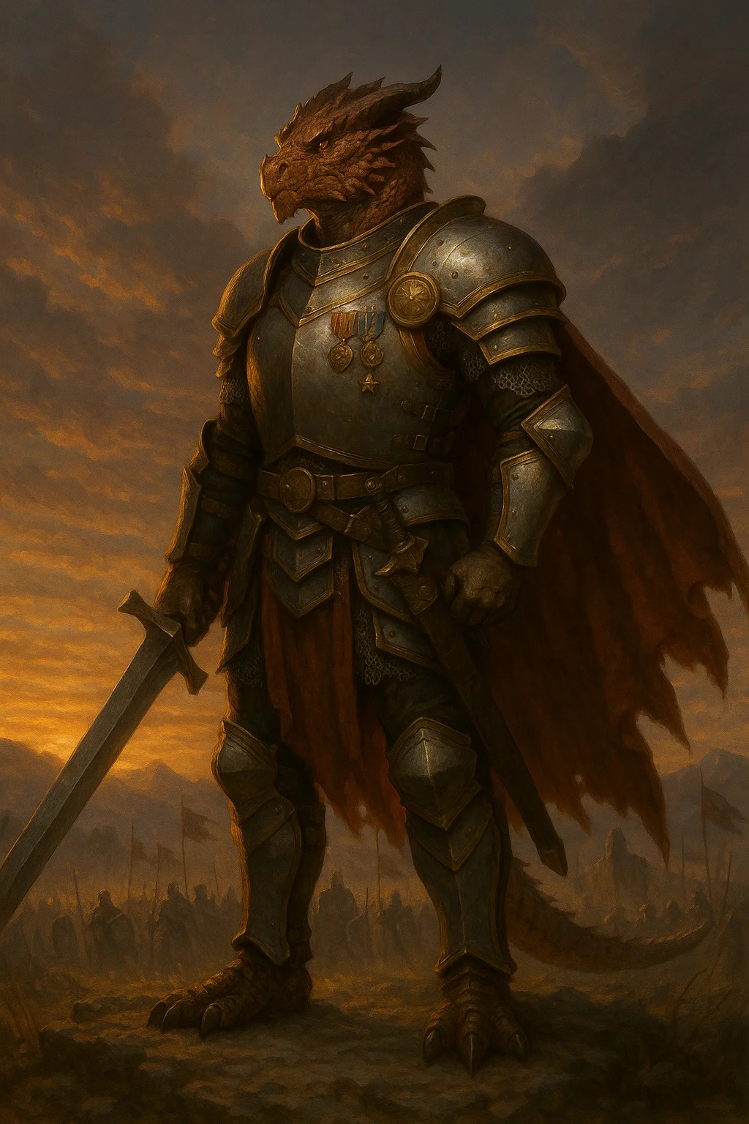

Medium humanoid (any race), lawful neutral

Armor Class 18 (plate armor)

Hit Points 143 (22d8 + 44)

Speed 30 ft.

|  |  |  |  |  |  |
| --- | --- | --- | --- | --- | --- |
| STR | DEX | CON | INT | WIS | CHA |
| 20 (+5) | 15 (+2) | 14 (+2) | 10 (+0) | 14 (+2) | 12 (+1) |

Saving Throws Strength +9, Constitution +6

Skills Athletics +9, Intimidation +5, Perception +6

Senses passive Perception 16

Languages Common

Challenge 9 (5,000 XP)

Indomitable (2/Day). The champion can reroll a saving throw. They must use the new roll.

Second Wind (Recharges after a Short or Long Rest). As a bonus action, the champion can regain 20 hit points.

**ACTIONS**

Multiattack. The champion makes three attacks with their greatsword or longbow.

Greatsword. Melee Weapon Attack: +9 to hit, reach 5 ft., one target. Hit: 12 (2d6 + 5) slashing damage.

Longbow. Ranged Weapon Attack: +6 to hit, range 150/600 ft., one target. Hit: 6 (1d8 + 2) piercing damage.

Rally (Recharges after a Short or Long Rest). The champion rallies their allies. Each ally within 30 feet regains 10 hit points and gains advantage on their next attack roll or saving throw.

**REACTIONS**

Parry. The champion adds 4 to their AC against one melee attack that would hit them.

**LORE**

Thaldros generals sometimes send their personal champions to deal with important threats or lead special missions. These warriors are the best of the bestveterans of countless battles, master tacticians, and nearly unbeatable in single combat.

**TACTICS**

- Challenge the strongest enemy

- Use Rally to support troops

- Fight honorably but ruthlessly

- Never surrender

**CAMPAIGN USE**

Both: Mini-boss, duel challenge, enemy leader

---

## Iron Crown Knight

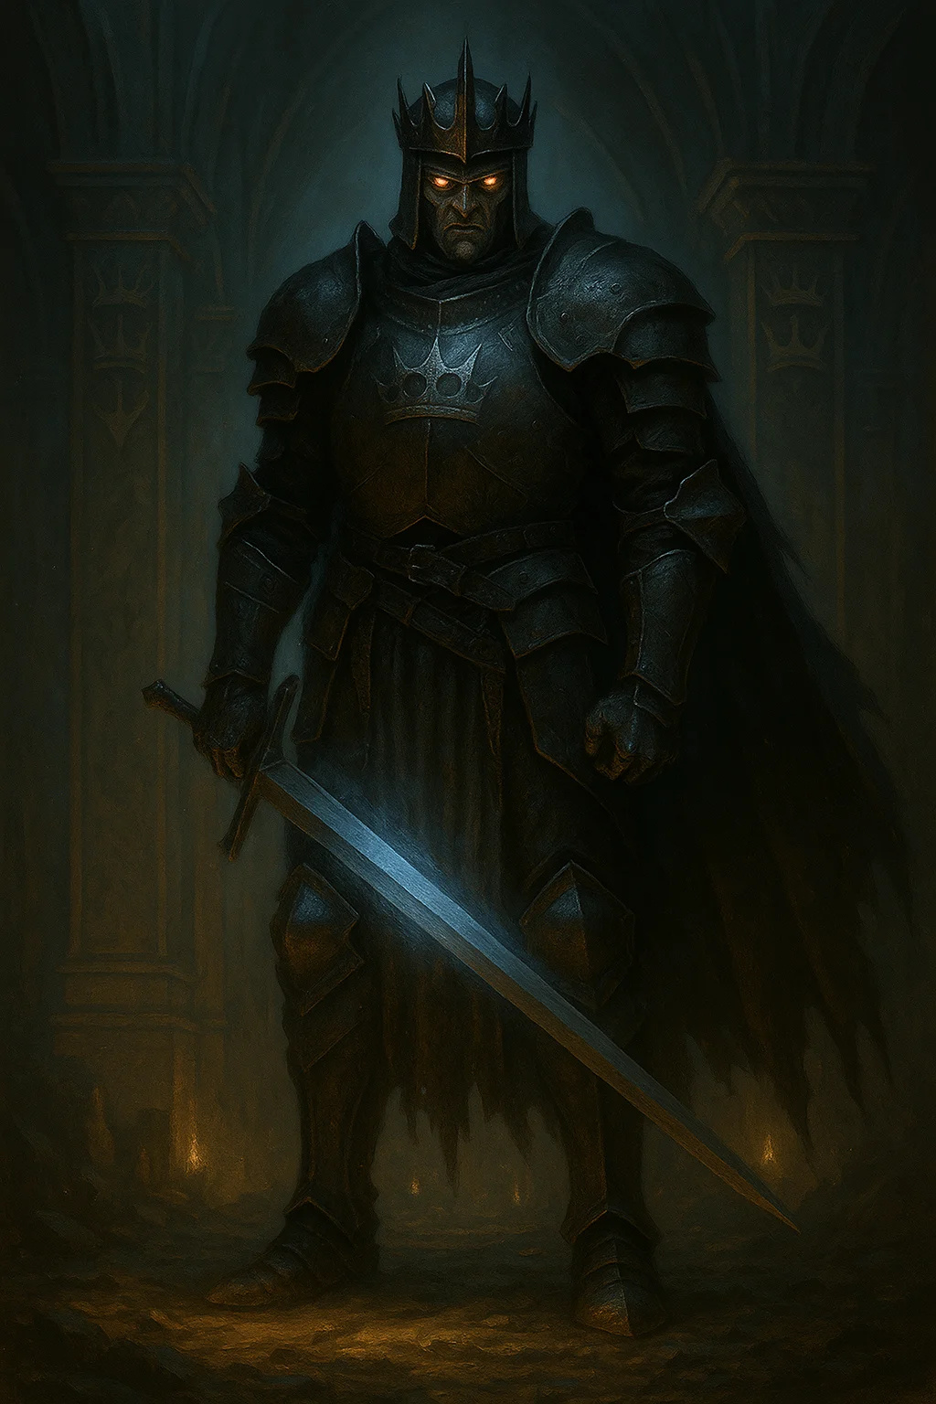

Medium humanoid (any race), lawful evil

Armor Class 20 (plate armor +2, shield)

Hit Points 153 (18d8 + 72)

Speed 30 ft.

|  |  |  |  |  |  |
| --- | --- | --- | --- | --- | --- |
| STR | DEX | CON | INT | WIS | CHA |
| 19 (+4) | 11 (+0) | 18 (+4) | 12 (+1) | 14 (+2) | 16 (+3) |

Saving Throws Constitution +8, Wisdom +6, Charisma +7

Skills Athletics +8, Intimidation +7, Religion +5

Damage Resistances necrotic

Condition Immunities frightened

Senses passive Perception 12

Languages Common

Challenge 10 (5,900 XP)

Aura of Tyranny (10 ft.). Allied creatures within 10 feet deal an extra 1d4 damage on weapon attacks. Enemy creatures have disadvantage on saving throws against being frightened.

Iron Will. The knight has advantage on saving throws against being charmed or frightened.

Spellcasting. The knight is a 12th-level spellcaster (Oath of the Iron Crown subclass). Spellcasting ability is Charisma (spell save DC 15, +7 to hit). Prepared spells:

1st level (4 slots): command, compelled duel, shield of faith

2nd level (3 slots): zone of truth, hold person

3rd level (3 slots): dispel magic, fear

**ACTIONS**

Multiattack. The knight makes two longsword attacks.

Longsword +2. Melee Weapon Attack: +10 to hit, reach 5 ft., one target. Hit: 10 (1d8 + 6) slashing damage, or 11 (1d10 + 6) slashing damage if used with two hands.

Channel Divinity: Iron Command (1/Day). Each hostile creature within 30 feet must make a DC 15 Wisdom saving throw. On a failure, the creature is paralyzed until the end of the knight's next turn.

**REACTIONS**

Oath of Protection. When a creature within 5 feet is hit by an attack, the knight can make that attack target them instead.

**LORE**

The Iron Crown Knights are Thaldros's holy warriors, fanatically devoted to the concept of ordered civilization through strength. They're paladins who've sworn the Oath of the Iron Crown and serve as both warriors and enforcers of imperial law.

**TACTICS**

- Use Aura of Tyranny to buff allies

- Command the battlefield

- Iron Command at start of combat

- Protect important allies

**CAMPAIGN USE**

Shattered Oaths: Major villain, recurring antagonist, final arc enemy

---

## Lord Commander Varius

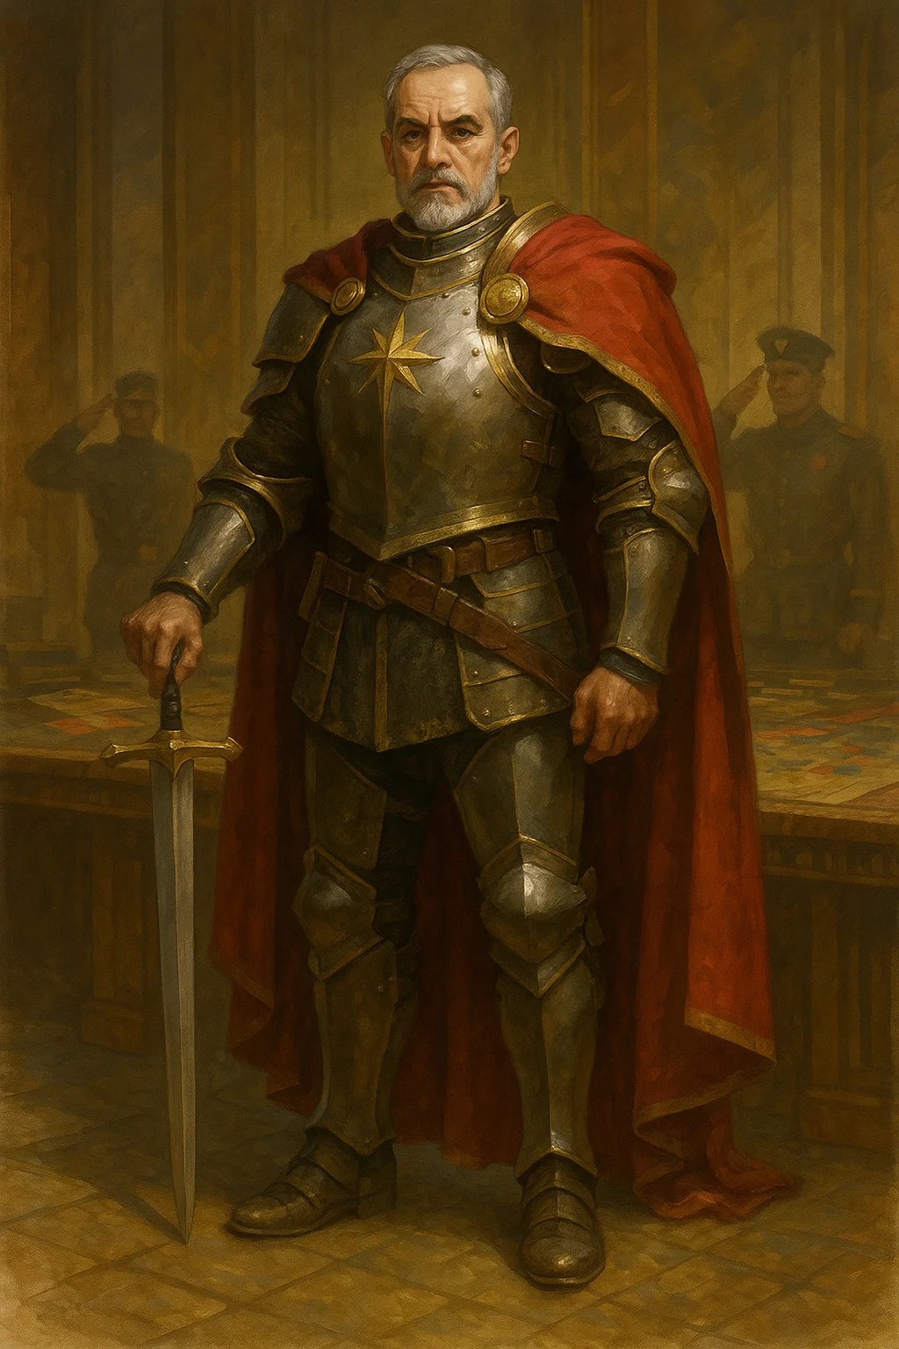

Medium humanoid (human), lawful neutral

Armor Class 21 (plate armor +3, shield +1)

Hit Points 187 (22d8 + 88)

Speed 30 ft.

|  |  |  |  |  |  |
| --- | --- | --- | --- | --- | --- |
| STR | DEX | CON | INT | WIS | CHA |
| 20 (+5) | 14 (+2) | 18 (+4) | 16 (+3) | 16 (+3) | 18 (+4) |

Saving Throws Strength +10, Constitution +9, Wisdom +8, Charisma +9

Skills Athletics +10, History +8, Insight +8, Intimidation +9, Perception +8

Damage Resistances all damage from spells

Condition Immunities frightened

Senses passive Perception 18

Languages Common, plus four others

Challenge 13 (10,000 XP)

Legendary Resistance (3/Day). If Varius fails a saving throw, he can choose to succeed instead.

Supreme Commander. Allied creatures within 60 feet have advantage on saving throws against being frightened and add 1d6 to damage rolls.

Tactical Genius. Varius can take a special reaction at initiative count 20 (losing ties) to command an ally within 60 feet to immediately take an action.

Magic Resistance. Varius has advantage on saving throws against spells and other magical effects.

**ACTIONS**

Multiattack. Varius makes three longsword attacks.

Longsword of Command +3. Melee Weapon Attack: +13 to hit, reach 5 ft., one target. Hit: 12 (1d8 + 8) slashing damage, or 13 (1d10 + 8) slashing damage if used with two hands, plus 9 (2d8) radiant damage.

Javelin of Lightning +2. Ranged Weapon Attack: +9 to hit, range 30/120 ft., one target. Hit: 7 (1d6 + 4) piercing damage plus 9 (2d8) lightning damage.

Commanding Shout (Recharge 5-6). Varius issues a tactical command. Each ally within 60 feet can immediately move up to half their speed and make one weapon attack as a reaction.

**LEGENDARY ACTIONS**

Varius can take 3 legendary actions, choosing from the options below. Only one legendary action can be used at a time and only at the end of another creature's turn. Varius regains spent legendary actions at the start of his turn.

Move. Varius moves up to half his speed.

Attack. Varius makes one longsword attack.

Rally (Costs 2 Actions). Each ally within 30 feet regains 15 hit points and gains advantage on their next attack roll.

Tactical Reposition (Costs 3 Actions). Varius and up to four allies within 60 feet can move up to their speed without provoking opportunity attacks.

**LORE**

Lord Commander Varius is Thaldros's supreme military leadera brilliant tactician, legendary warrior, and unshakeable loyalist. He's not evil, but he genuinely believes in Thaldros's vision of ordered civilization. Many soldiers would die for him, and even his enemies respect him.

In Blood & Coin, he may hire the party for missions or become an honorable foe.

In Shattered Oaths, he's a major antagonistthe final military obstacle before the true villain.

**TACTICS**

- Command the battlefield

- Use Tactical Genius and Legendary Actions to control action economy

- Rally troops when needed

- Lead from the front but strategically

- Respect worthy opponents

**CAMPAIGN USE**

Both: Major boss fight, final act antagonist, recurring enemy leader

# Aethoria Resistance

## Aethorian Militia

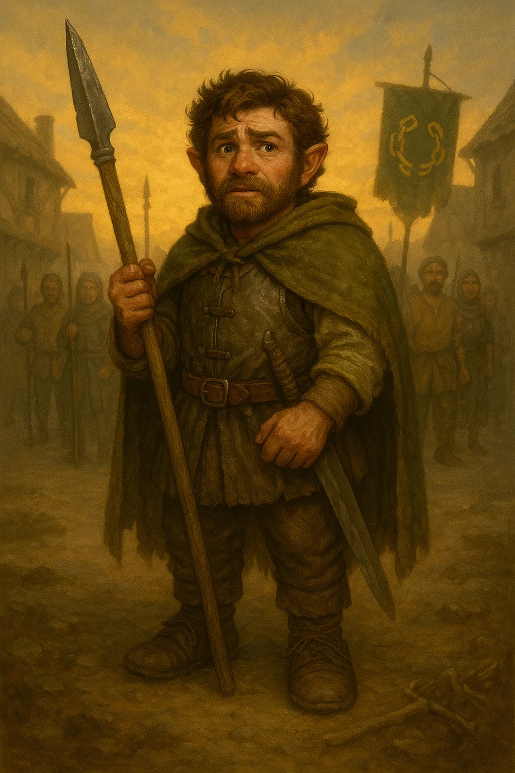

Medium humanoid, any alignment | CR 1/4

AC 12 (leather armor) | HP 9 (2d8) | Speed 30 ft.

|  |  |  |  |  |  |
| --- | --- | --- | --- | --- | --- |
| STR | DEX | CON | INT | WIS | CHA |
| 11 (+0) | 14 (+2) | 10 (+0) | 10 (+0) | 12 (+1) | 11 (+0) |

Skills Stealth +4, Survival +3

Languages Common

Challenge 1/4 (50 XP)

Guerrilla Fighter. Advantage on attacks when hidden or unseen by target.

**ACTIONS**

Spear. Melee Weapon Attack: +4 to hit, reach 5 ft., one target. Hit: 1d6+2 piercing damage

Sling. Ranged Weapon Attack: +4 to hit, range 30/120 ft., one target. Hit: 1d4+2 bludgeoning damage

**LORE**

Untrained civilians who took up arms. Brave but inexperienced.

**TACTICS**

Hit and run, use terrain, protect each other

**CAMPAIGN USE**

Common resistance encounters, moral complexity (they're fighting for freedom)

---

## Resistance Fighter

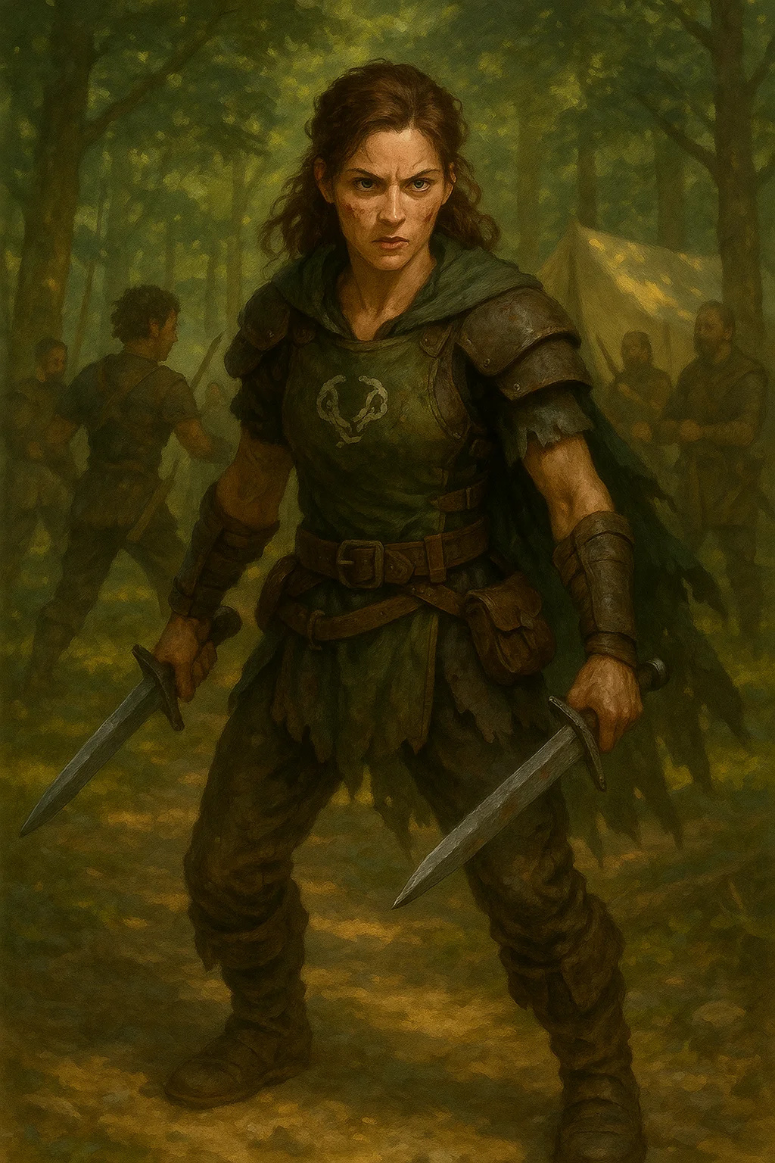

Medium humanoid, any good alignment | CR 1

AC 14 (leather armor) | HP 16 (3d8 + 3) | Speed 30 ft.

|  |  |  |  |  |  |
| --- | --- | --- | --- | --- | --- |
| STR | DEX | CON | INT | WIS | CHA |
| 12 (+1) | 15 (+2) | 12 (+1) | 11 (+0) | 13 (+1) | 12 (+1) |

Skills Stealth +4, Survival +3

Languages Common

Challenge 1 (200 XP)

Freedom's Fury. Extra 1d6 damage against Thaldros forces.

**ACTIONS**

Shortsword. Melee Weapon Attack: +4 to hit, reach 5 ft., one target. Hit: 1d6+2 piercing damage

Shortbow. Ranged Weapon Attack: +4 to hit, range 80/320 ft., one target. Hit: 1d6+2 piercing damage

Inspiring Cry (Recharge 5-6). Allies within 30 ft gain advantage on next attack.

**LORE**

More experienced than militia. Fighting for families and freedom.

**CAMPAIGN USE**

Ally NPCs in Shattered Oaths, honorable enemies in Blood & Coin

---

## People's Champion



Medium humanoid, chaotic good | CR 3

AC 16 (chainmail) | HP 58 (9d8 + 18) | Speed 30 ft.

|  |  |  |  |  |  |
| --- | --- | --- | --- | --- | --- |
| STR | DEX | CON | INT | WIS | CHA |
| 16 (+3) | 13 (+1) | 14 (+2) | 10 (+0) | 12 (+1) | 15 (+2) |

Saves Strength +5, Constitution +4

Skills Athletics +5, Persuasion +4

Languages Common

Challenge 3 (700 XP)

Defender of the Weak. Advantage on attacks against enemies threatening civilians.

**ACTIONS**

Multiattack. Two longsword attacks.

Longsword. Melee Weapon Attack: +5 to hit, reach 5 ft., one target. Hit: 1d8+3 slashing damage

Rally the People (1/Day). All allies within 30 ft gain 10 temp HP and advantage on saves vs fear.

**LORE**

Local heroes who stood up to tyranny. Inspirational leaders.

**CAMPAIGN USE**

Quest givers, allies, or targets to rescue in Shattered Oaths

---

## Revolutionary Mage

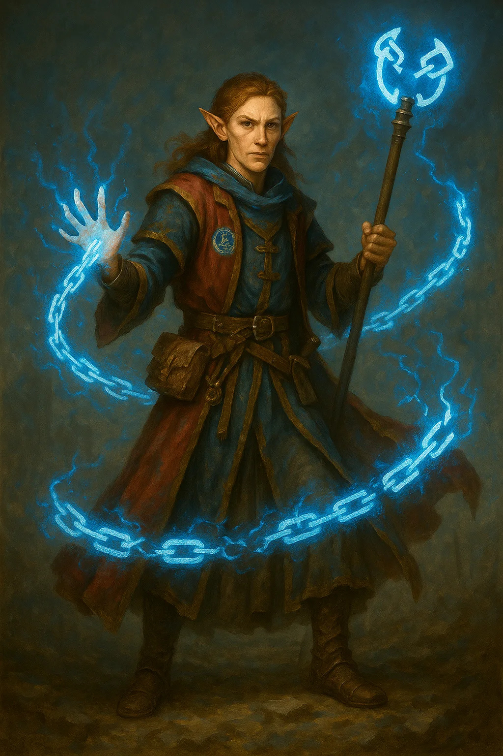

Medium humanoid, chaotic good | CR 5

AC 12 (15 with mage armor) | HP 49 (11d8) | Speed 30 ft.

|  |  |  |  |  |  |
| --- | --- | --- | --- | --- | --- |
| STR | DEX | CON | INT | WIS | CHA |
| 9 (-1) | 14 (+2) | 11 (+0) | 17 (+3) | 12 (+1) | 11 (+0) |

Saves Intelligence +6, Wisdom +4

Skills Arcana +6, History +6

Languages Common +2 others

Challenge 5 (1,800 XP)

Spellcasting. 9th-level wizard (DC 14, +6 attack):

Cantrips: fire bolt, mage hand, message, light

1st (4): magic missile, shield, mage armor

2nd (3): scorching ray, misty step

3rd (3): fireball, counterspell

4th (3): greater invisibility

5th (1): wall of force

Liberation Magic. Can cast knock and dispel magic at will.

**LORE**

Aethorian mages who use magic to free the oppressed.

**CAMPAIGN USE**

Powerful allies or quest givers in Shattered Oaths

---

## Chain Breaker Monk

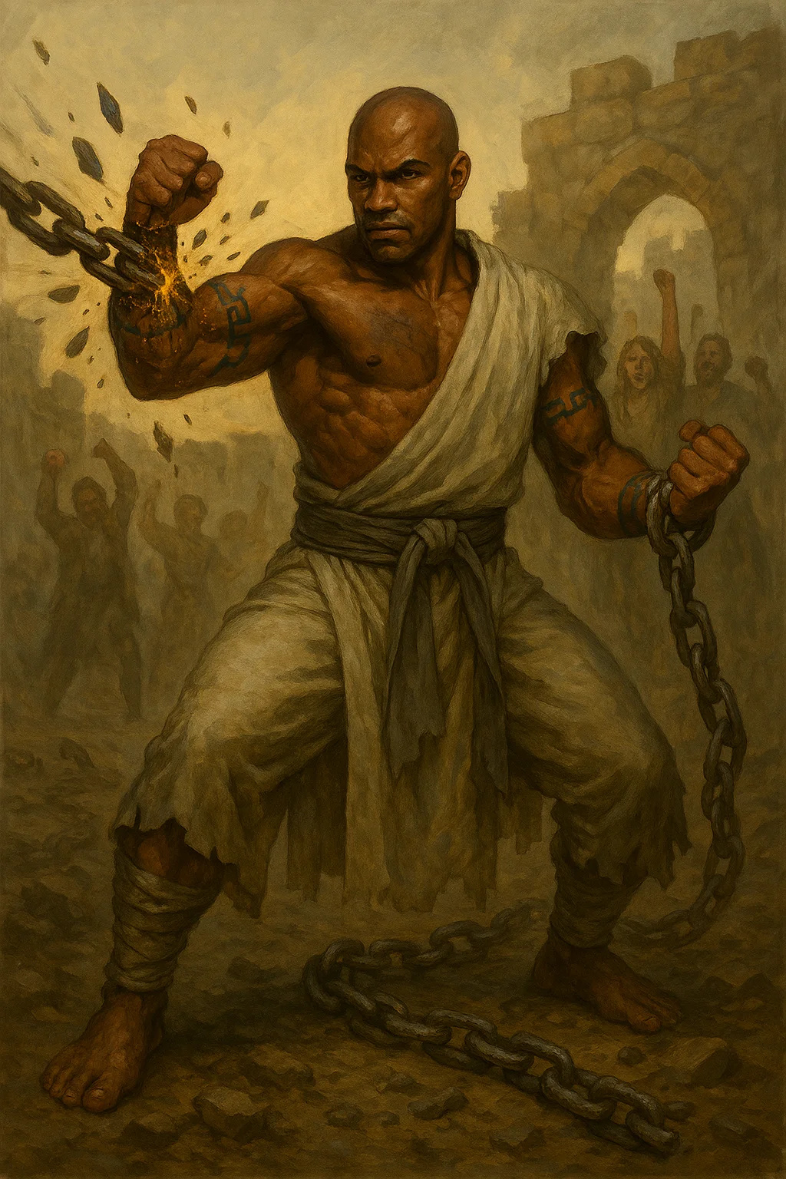

Medium humanoid, lawful good | CR 6

AC 17 | HP 91 (14d8 + 28) | Speed 50 ft.

|  |  |  |  |  |  |
| --- | --- | --- | --- | --- | --- |
| STR | DEX | CON | INT | WIS | CHA |
| 11 (+0) | 18 (+4) | 14 (+2) | 13 (+1) | 17 (+3) | 12 (+1) |

Saves Strength +3, Dexterity +7

Skills Acrobatics +7, Stealth +7

Languages Common

Challenge 6 (2,300 XP)

Unarmored Defense. AC = 10 + Dexterity + Wisdom

Unarmored Movement. +20 ft speed

Ki (11 points). Regain on short rest.

**ACTIONS**

Multiattack. Four unarmed strikes.

Unarmed Strike. Melee Weapon Attack: +7 to hit, reach 5 ft., one target. Hit: 1d8+4 bludgeoning damage

Shatter Bonds (3 ki). Automatically break all restraints on touched creature. Can use on self.

Stunning Strike (1 ki). DC 15 Constitution save or stunned until end of your next turn.

**LORE**

Former slaves who mastered martial arts. Dedicated to freeing others.

**CAMPAIGN USE**

Powerful ally in Shattered Oaths, helps with prison breaks

---

## Guerrilla Commander

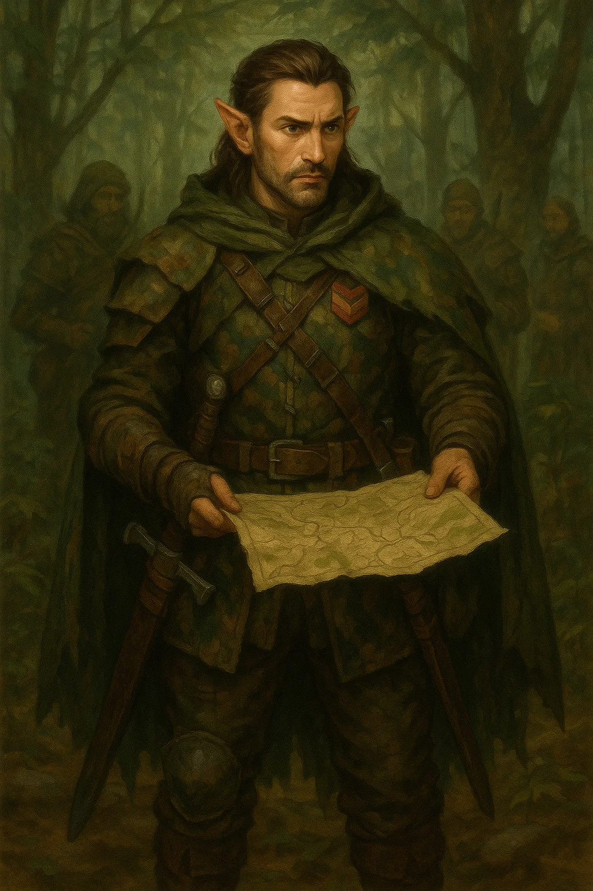

Medium humanoid, chaotic good | CR 7

AC 16 (studded leather +1) | HP 117 (18d8 + 36) | Speed 30 ft.

|  |  |  |  |  |  |
| --- | --- | --- | --- | --- | --- |
| STR | DEX | CON | INT | WIS | CHA |
| 14 (+2) | 18 (+4) | 14 (+2) | 15 (+2) | 16 (+3) | 17 (+3) |

Saves Dexterity +7, Wisdom +6

Skills Stealth +10, Survival +6, Persuasion +6

Languages Common +2 others

Challenge 7 (2,900 XP)

Tactical Mind. Allies within 60 ft add +2 to initiative.

Sneak Attack (1/turn). +4d6 damage with advantage.

**ACTIONS**

Multiattack. Three shortsword or shortbow attacks.

Shortsword +2. Melee Weapon Attack: +9 to hit, reach 5 ft., one target. Hit: 1d6+6 piercing damage

Strategic Command (Recharge 5-6). All allies within 60 ft can move half speed and make one attack as reaction.

**LORE**

Brilliant guerrilla leader. Master of ambush and hit-and-run tactics.

**CAMPAIGN USE**

Quest giver, mentor, or allied commander in Shattered Oaths

---

## The Liberator

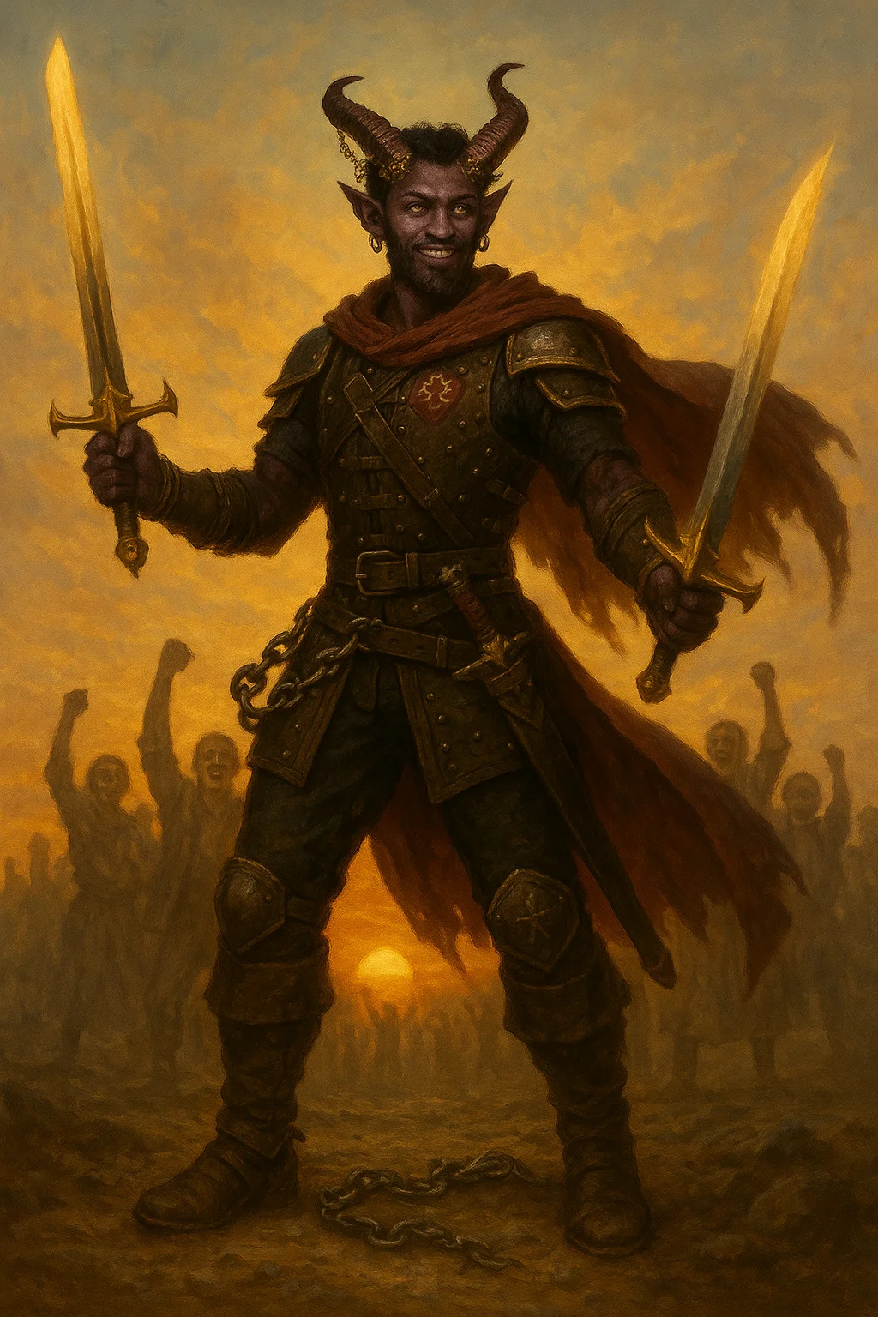

Medium humanoid, chaotic good | CR 11

AC 19 (studded leather +3) | HP 178 (21d8 + 84) | Speed 40 ft.

|  |  |  |  |  |  |
| --- | --- | --- | --- | --- | --- |
| STR | DEX | CON | INT | WIS | CHA |
| 16 (+3) | 20 (+5) | 18 (+4) | 14 (+2) | 16 (+3) | 20 (+5) |

Saves Dexterity +10, Wisdom +8, Charisma +10

Skills All +9 or higher

Damage Resistances psychic | Languages All common

Challenge 11 (7,200 XP)

Legendary Resistance (2/Day). Can choose to succeed on failed save.

Aura of Freedom (30 ft). Allies have advantage vs charmed/frightened.

Sneak Attack (1/turn). +6d6 damage

**ACTIONS**

Multiattack. Four rapier attacks.

Freedom's Blade +3. Melee Weapon Attack: +12 to hit, reach 5 ft., one target. Hit: 1d8+8 piercing damage + 2d8 radiant damage

Break All Chains (1/Day). All restraints/prisons within 60 ft shatter. All allies gain 30 temp HP.

**LEGENDARY ACTIONS (3/round):**

Move. Half speed

Attack. One rapier attack

Inspire (2 actions). One ally makes attack or spell as reaction

**LORE**

Legendary resistance leader. Symbol of hope for all oppressed people.

**CAMPAIGN USE**

Major ally/NPC in Shattered Oaths final act

---

## Prophesied Hero

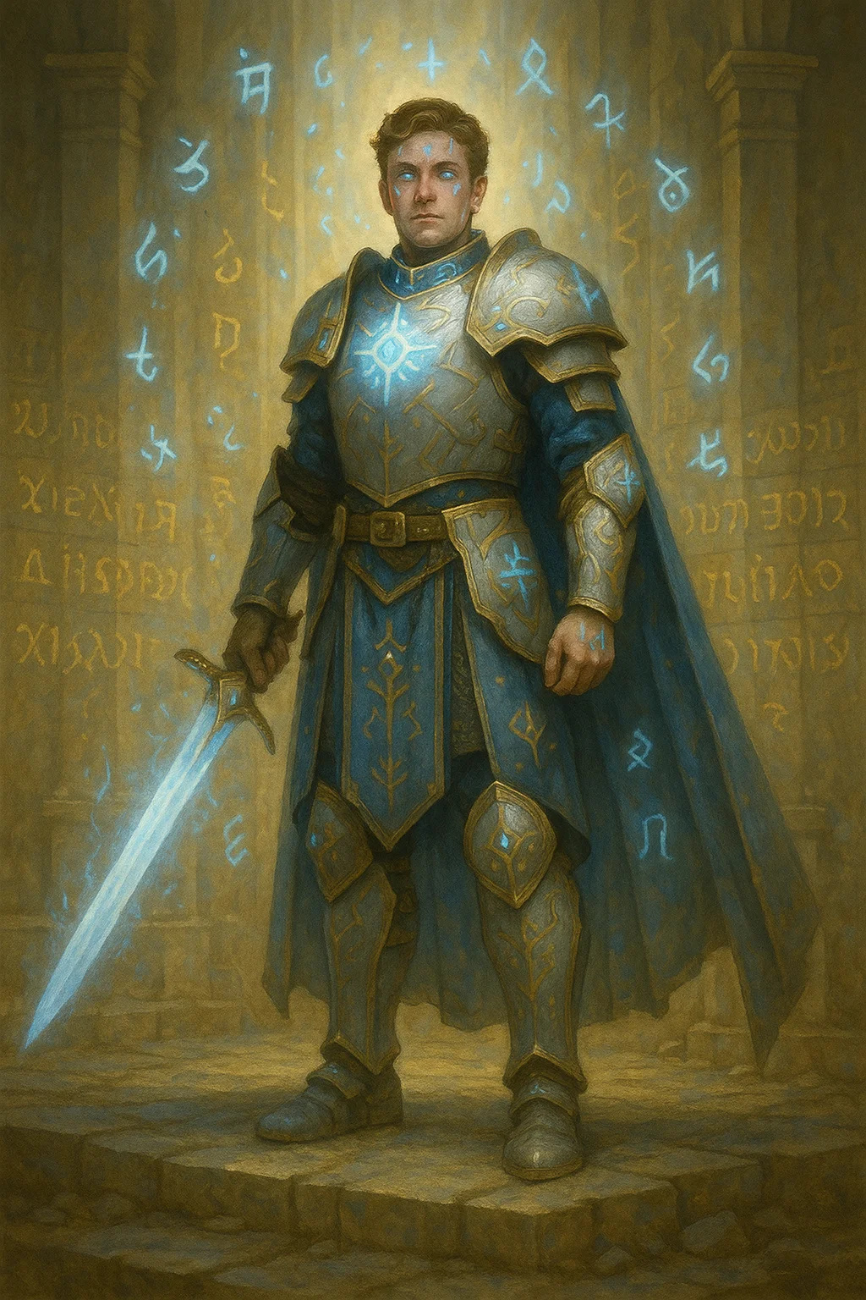

Medium humanoid, any good | CR 12

AC 20 (plate +1, shield +1) | HP 210 (20d8 + 120) | Speed 30 ft.

|  |  |  |  |  |  |
| --- | --- | --- | --- | --- | --- |
| STR | DEX | CON | INT | WIS | CHA |
| 20 (+5) | 14 (+2) | 22 (+6) | 12 (+1) | 18 (+4) | 20 (+5) |

Saves Strength +10, Constitution +11, Wisdom +9, Charisma +10 | Condition Immunities frightened

Languages Common +3 others

Challenge 12 (8,400 XP)

Destiny's Chosen. Advantage on all saves. Crits on 19-20.

Aura of Destiny (30 ft). Allies add +3 to all saves.

**ACTIONS**

Multiattack. Three longsword attacks.

Destiny's Blade +2. Melee Weapon Attack: +12 to hit, reach 5 ft., one target. Hit: 1d8+7 slashing damage + 3d8 radiant damage

Channel Divinity: Smite the Tyrant (3/Day). Next attack deals +50 radiant damage vs evil targets.

**LORE**

One of "the Seven" from prophecy. Destined hero.

**CAMPAIGN USE**

Potential PC, major ally NPC, or example of what heroes can become

---

# Iron Guild Mercenaries

## Guild Recruit

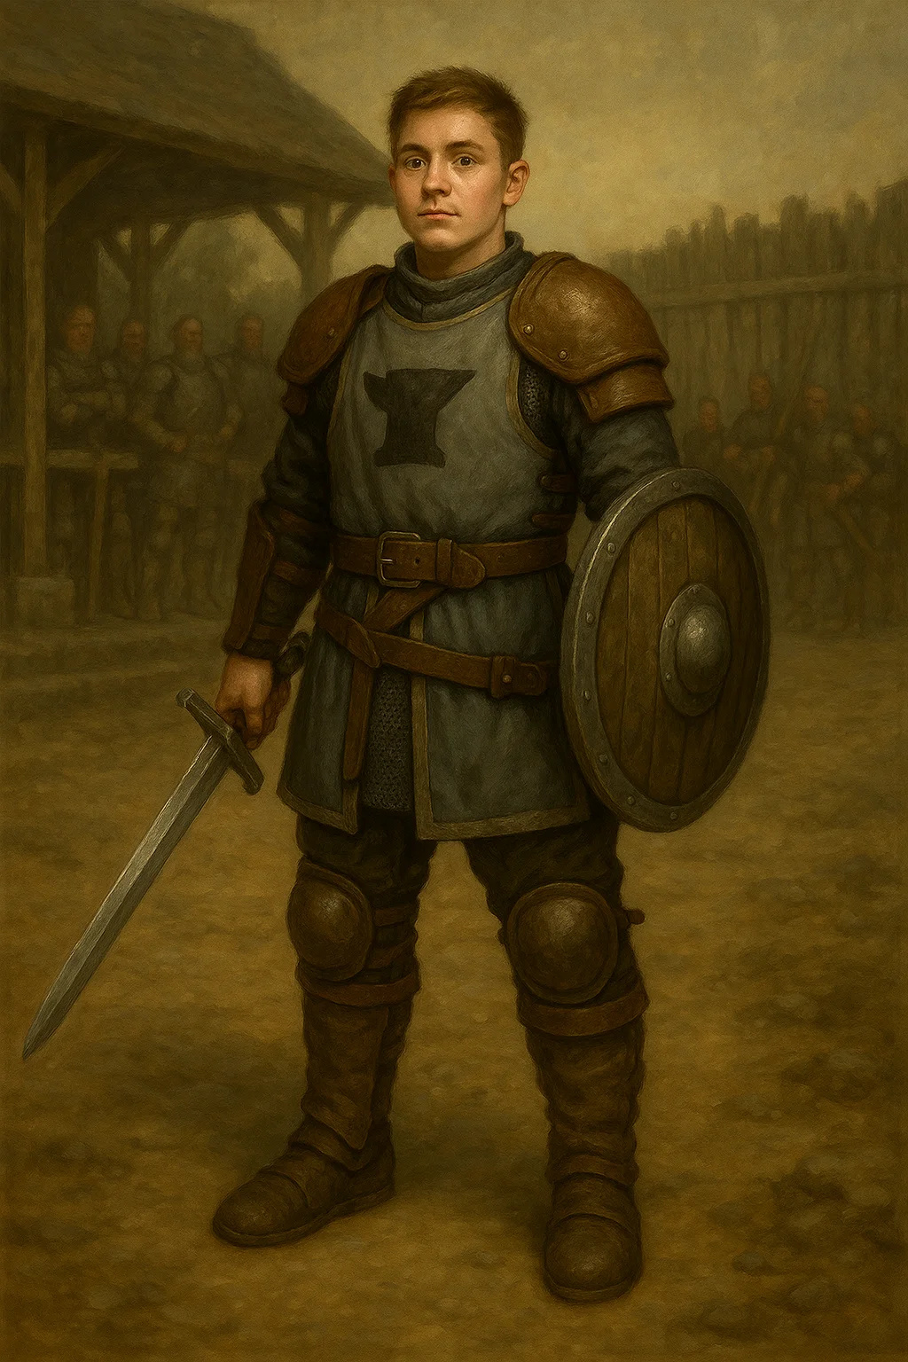

Medium humanoid, any | CR 1/2

AC 14 (leather, shield) | HP 16 (3d8 + 3) | Speed 30 ft.

|  |  |  |  |  |  |
| --- | --- | --- | --- | --- | --- |
| STR | DEX | CON | INT | WIS | CHA |
| 13 (+1) | 12 (+1) | 12 (+1) | 10 (+0) | 11 (+0) | 10 (+0) |

Skills Athletics +3

Languages Common

Challenge 1/2 (100 XP)

Professional Training. Advantage on saves vs fear while within 10 ft of ally.

**ACTIONS**

Longsword. Melee Weapon Attack: +3 to hit, reach 5 ft., one target. Hit: 1d8+1 slashing damage

Crossbow. Ranged Weapon Attack: +3 to hit, range 80/320 ft., one target. Hit: 1d8+1 piercing damage

**LORE**

New mercenaries learning the trade. Disciplined and eager to prove themselves.

**CAMPAIGN USE**

Common encounters in Blood & Coin, can be convinced to stand down

---

## Veteran Mercenary

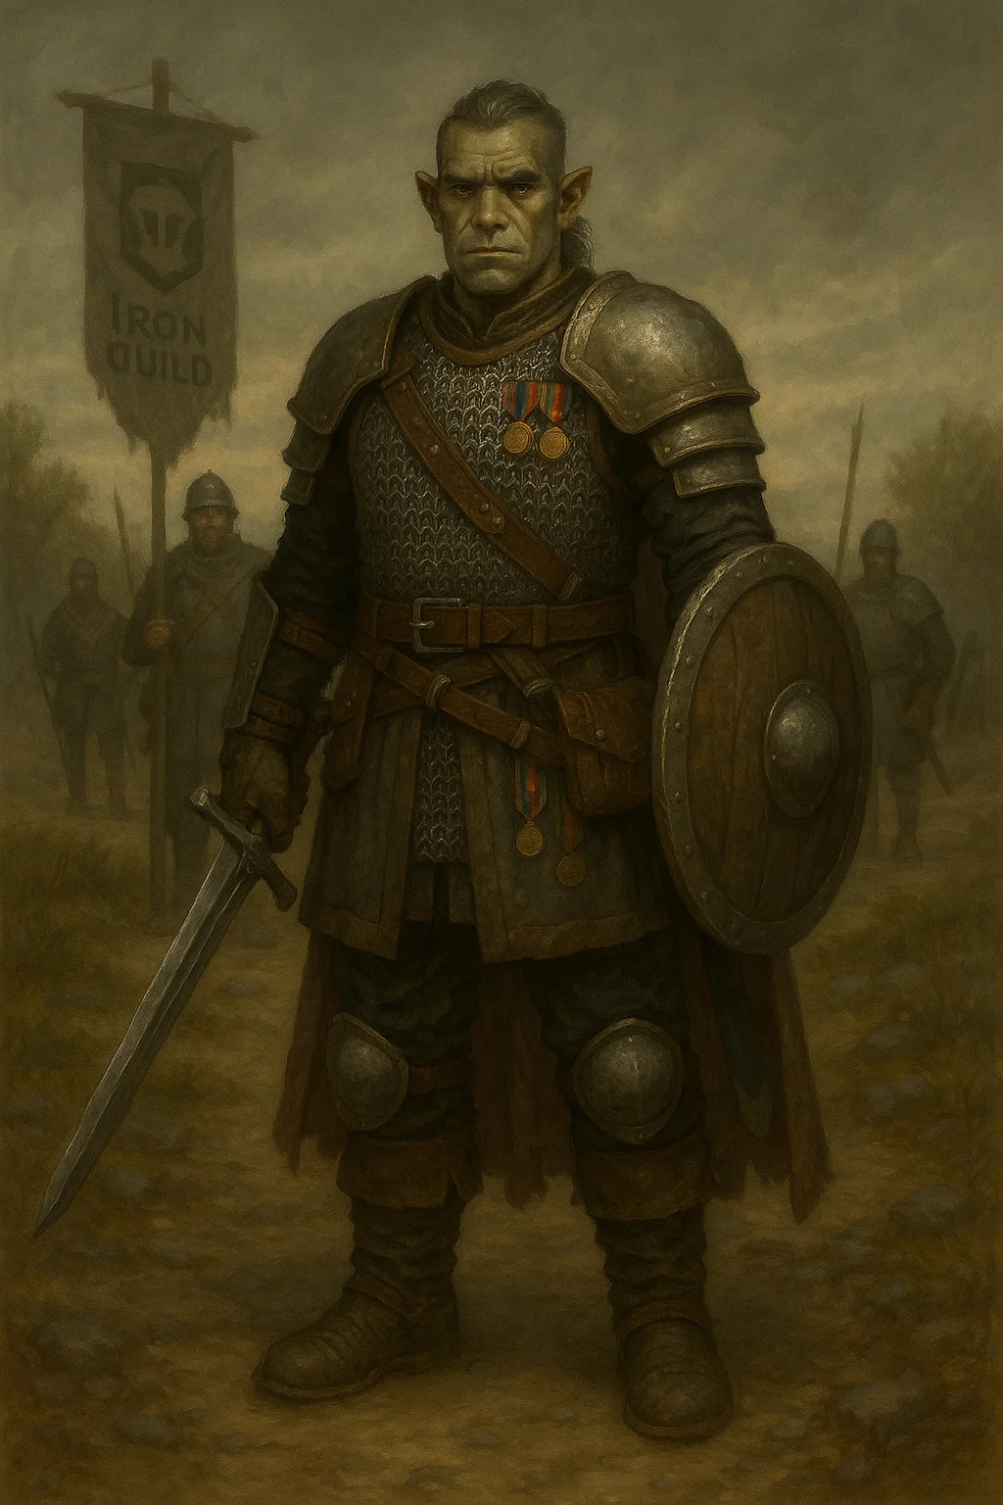

Medium humanoid, any | CR 2

AC 16 (chain shirt, shield) | HP 45 (7d8 + 14) | Speed 30 ft.

|  |  |  |  |  |  |
| --- | --- | --- | --- | --- | --- |
| STR | DEX | CON | INT | WIS | CHA |
| 15 (+2) | 13 (+1) | 14 (+2) | 11 (+0) | 12 (+1) | 11 (+0) |

Skills Athletics +4, Survival +3

Languages Common

Challenge 2 (450 XP)

Combat Veteran. Advantage on saves vs poison and disease.

**ACTIONS**

Multiattack. Two longsword attacks.

Longsword. Melee Weapon Attack: +4 to hit, reach 5 ft., one target. Hit: 1d8+2 slashing damage

Tactical Retreat. Disengage as bonus action.

**LORE**

Experienced fighters who've survived many contracts.

**CAMPAIGN USE**

Standard mercenary encounters, potential allies in Blood & Coin

---

## Guild Enforcer

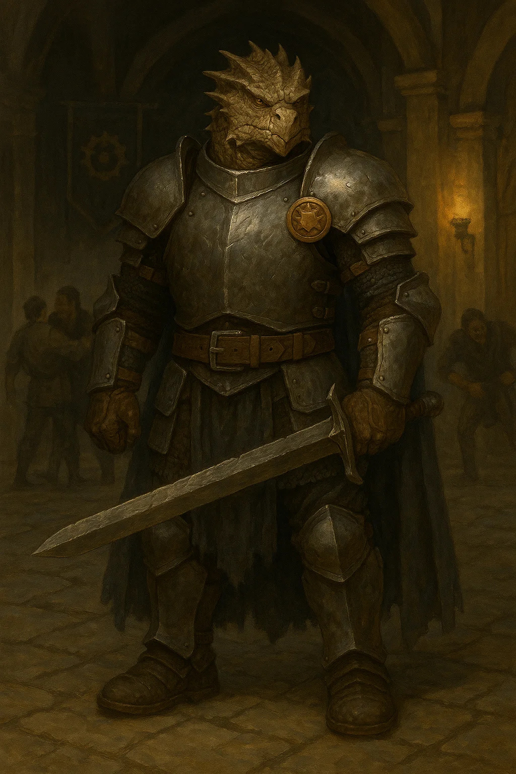

Medium humanoid, any | CR 4

AC 17 (half plate) | HP 68 (8d8 + 32) | Speed 30 ft.

|  |  |  |  |  |  |
| --- | --- | --- | --- | --- | --- |
| STR | DEX | CON | INT | WIS | CHA |
| 17 (+3) | 14 (+2) | 18 (+4) | 11 (+0) | 13 (+1) | 12 (+1) |

Skills Athletics +5, Intimidation +3 | Languages Common

Challenge 4 (1,100 XP)

Guild Authority. Can call for backup (1d4 recruits arrive in 1d4 rounds).

**ACTIONS**

Multiattack. Two greatsword attacks.

Greatsword. Melee Weapon Attack: +5 to hit, reach 5 ft., one target. Hit: 2d6+3 slashing damage

Intimidating Presence (Recharge 5-6). DC 13 Wisdom save or frightened 1 min.

**LORE**

Enforce Guild rules and handle troublemakers.

**CAMPAIGN USE**

Boss fights for lower levels, guild authority figures

---

## Contract Killer

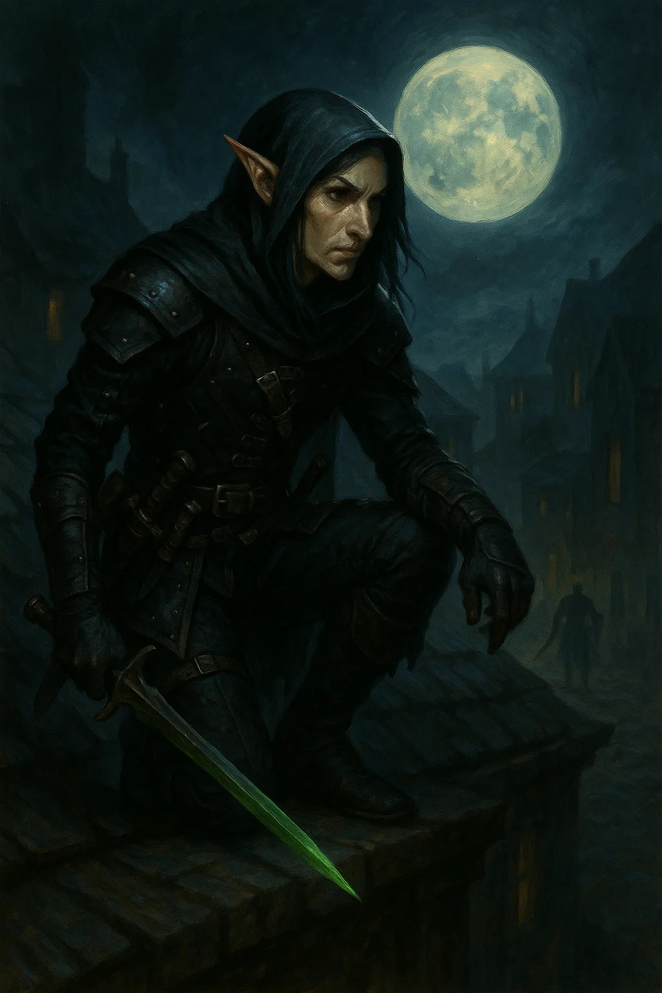

Medium humanoid, any | CR 5

AC 15 (studded leather) | HP 78 (12d8 + 24) | Speed 30 ft.

|  |  |  |  |  |  |
| --- | --- | --- | --- | --- | --- |
| STR | DEX | CON | INT | WIS | CHA |
| 11 (+0) | 16 (+3) | 14 (+2) | 13 (+1) | 11 (+0) | 10 (+0) |

Saves Dexterity +6

Skills Stealth +9, Perception +3

Languages Common, Thieves' Cant

Challenge 5 (1,800 XP)

Assassinate. Advantage vs creatures that haven't acted. Crits on surprise hits.

Sneak Attack (1/turn). +3d6 damage with advantage.

**ACTIONS**

Multiattack. Two shortsword attacks.

Shortsword. Melee Weapon Attack: +6 to hit, reach 5 ft., one target. Hit: 1d6+3 piercing damage

Poisoned Dart. Ranged Weapon Attack: +6 to hit, range 20/60 ft., one target. Hit: 1d4+3 piercing damage + DC 14 Constitution save or 3d6 poison damage

**LORE**

Guild assassins for special contracts. Professional and ruthless.

**CAMPAIGN USE**

Assassination attempts, high-stakes contracts in Blood & Coin

---

## Iron Guild Captain

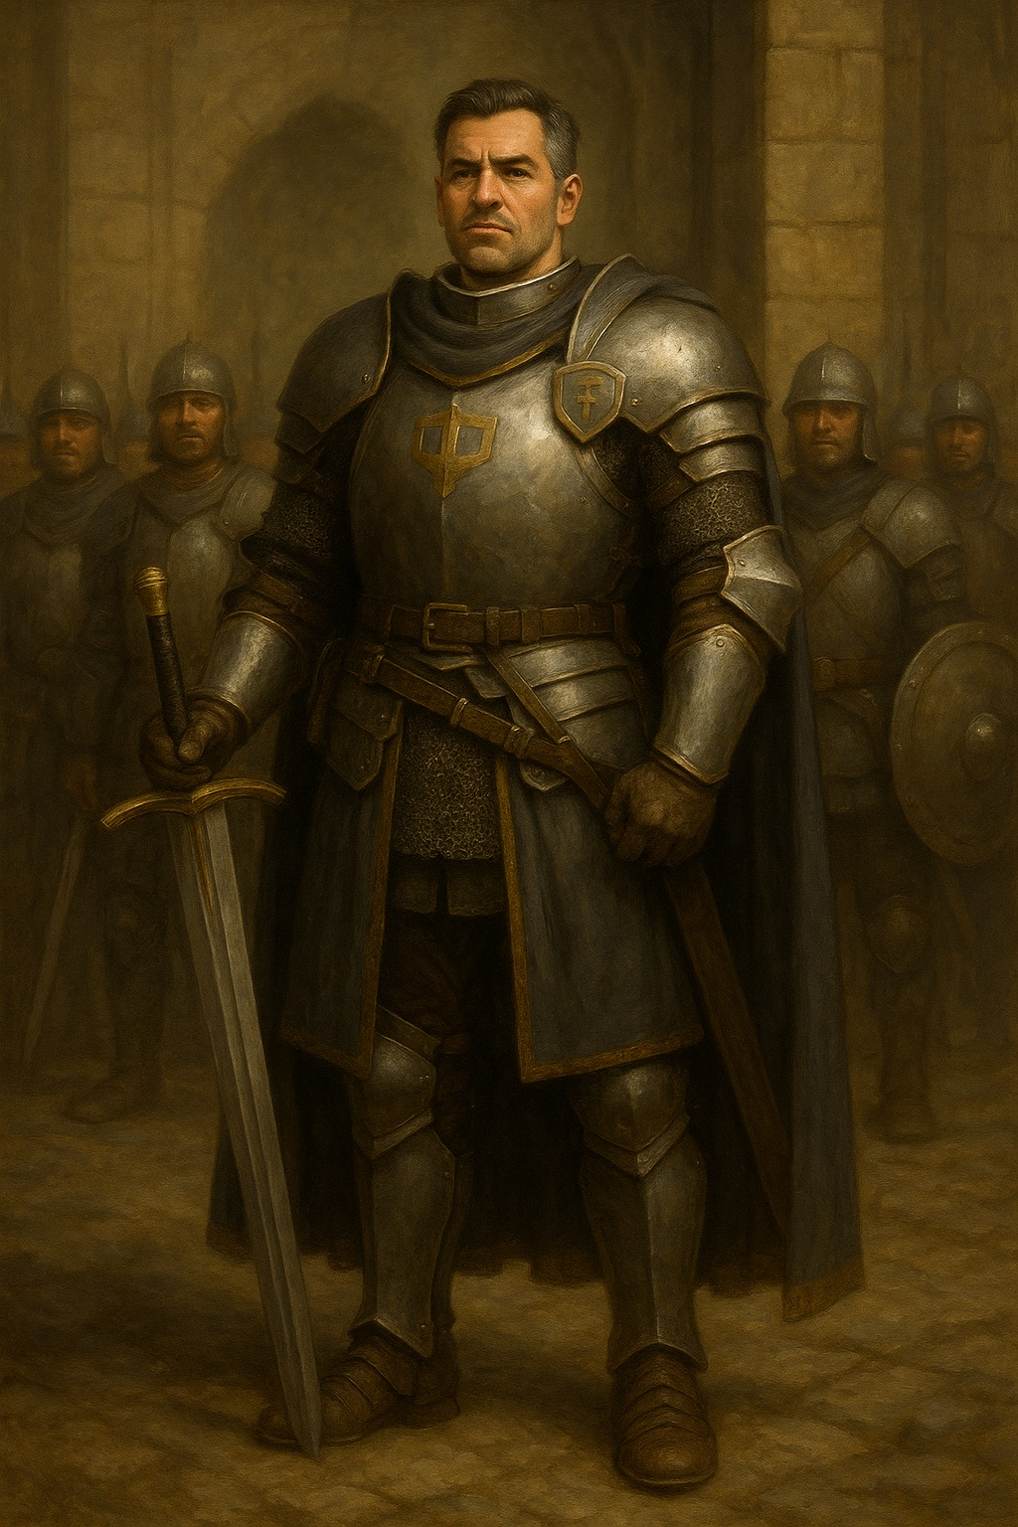

Medium humanoid, any | CR 7

AC 18 (plate) | HP 135 (18d8 + 54) | Speed 30 ft.

|  |  |  |  |  |  |
| --- | --- | --- | --- | --- | --- |
| STR | DEX | CON | INT | WIS | CHA |
| 18 (+4) | 12 (+1) | 16 (+3) | 14 (+2) | 15 (+2) | 16 (+3) |

Saves Strength +7, Constitution +6, Wisdom +5

Skills Athletics +7, Persuasion +6

Languages Common +2 others

Challenge 7 (2,900 XP)

Tactical Leader. Allies within 30 ft add +2 to attack rolls.

Second Wind (1/Short Rest). Bonus action to heal 20 HP.

**ACTIONS**

Multiattack. Three longsword attacks.

Longsword +1. Melee Weapon Attack: +8 to hit, reach 5 ft., one target. Hit: 1d8+5 slashing damage

Command Squad (Recharge 5-6). All allies within 60 ft can attack as reaction.

**LORE**

Lead mercenary squads. Respected tacticians and fighters.

**CAMPAIGN USE**

Quest givers, rival mercenaries, bosses in Blood & Coin

---

## Guildmaster's Elite

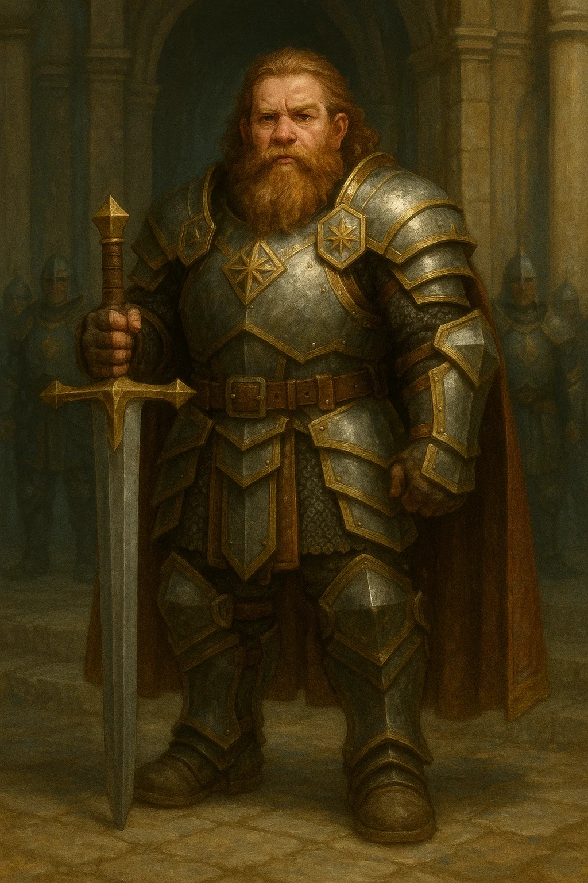

Medium humanoid, any | CR 9

AC 19 (plate +1) | HP 165 (22d8 + 66) | Speed 30 ft.

|  |  |  |  |  |  |
| --- | --- | --- | --- | --- | --- |
| STR | DEX | CON | INT | WIS | CHA |
| 20 (+5) | 14 (+2) | 16 (+3) | 12 (+1) | 14 (+2) | 15 (+2) |

Saves Strength +9, Constitution +7

Skills Athletics +9, Intimidation +6

Languages Common +2 others

Challenge 9 (5,000 XP)

Indomitable (2/Day). Reroll failed save.

Mercenary's Pride. Advantage vs fear and charm.

**ACTIONS**

Multiattack. Three greatsword attacks.

Greatsword +2. Melee Weapon Attack: +11 to hit, reach 5 ft., one target. Hit: 2d6+7 slashing damage

Commanding Strike (Recharge 5-6). One ally makes attack with advantage.

**LORE**

The Guildmaster's personal guard. Legendary mercenaries.

**CAMPAIGN USE**

Major bosses, final encounters in Blood & Coin

---

## Garrick Ironheart (guildmaster)

Medium humanoid (dwarf), lawful neutral | CR 11

AC 20 (plate +2, shield +1) | HP 195 (23d8 + 92) | Speed 25 ft.

|  |  |  |  |  |  |
| --- | --- | --- | --- | --- | --- |
| STR | DEX | CON | INT | WIS | CHA |
| 20 (+5) | 12 (+1) | 18 (+4) | 16 (+3) | 16 (+3) | 18 (+4) |

Saves All +7 or higher

Skills Insight +11, Persuasion +12

Damage Resistances poison | Languages Common, Dwarvish +3

Challenge 11 (7,200 XP)

Legendary Resistance (2/Day). Choose to succeed on failed save.

Guildmaster's Authority. All Iron Guild members within 60 ft gain +3 to all rolls.

**ACTIONS**

Multiattack. Three warhammer attacks.

Iron Will +3. Melee Weapon Attack: +12 to hit, reach 5 ft., one target. Hit: 1d8+8 bludgeoning damage + 2d8 force damage

Honor Duel (1/Day). Challenge one creature. Both have advantage vs each other, disadvantage vs others. Lasts 1 min.

**LEGENDARY ACTIONS (3/round):**

Attack. One warhammer attack

Tactical Order (2 actions). One ally acts immediately

Iron Defense (2 actions). +5 AC until next turn

**LORE**

Founded Iron Guild. Legendary warrior and fair leader. Respected even by enemies.

**CAMPAIGN USE**

Major NPC, quest giver, or final boss in Blood & Coin

# Ascended-Touched

## Blessed Paladin

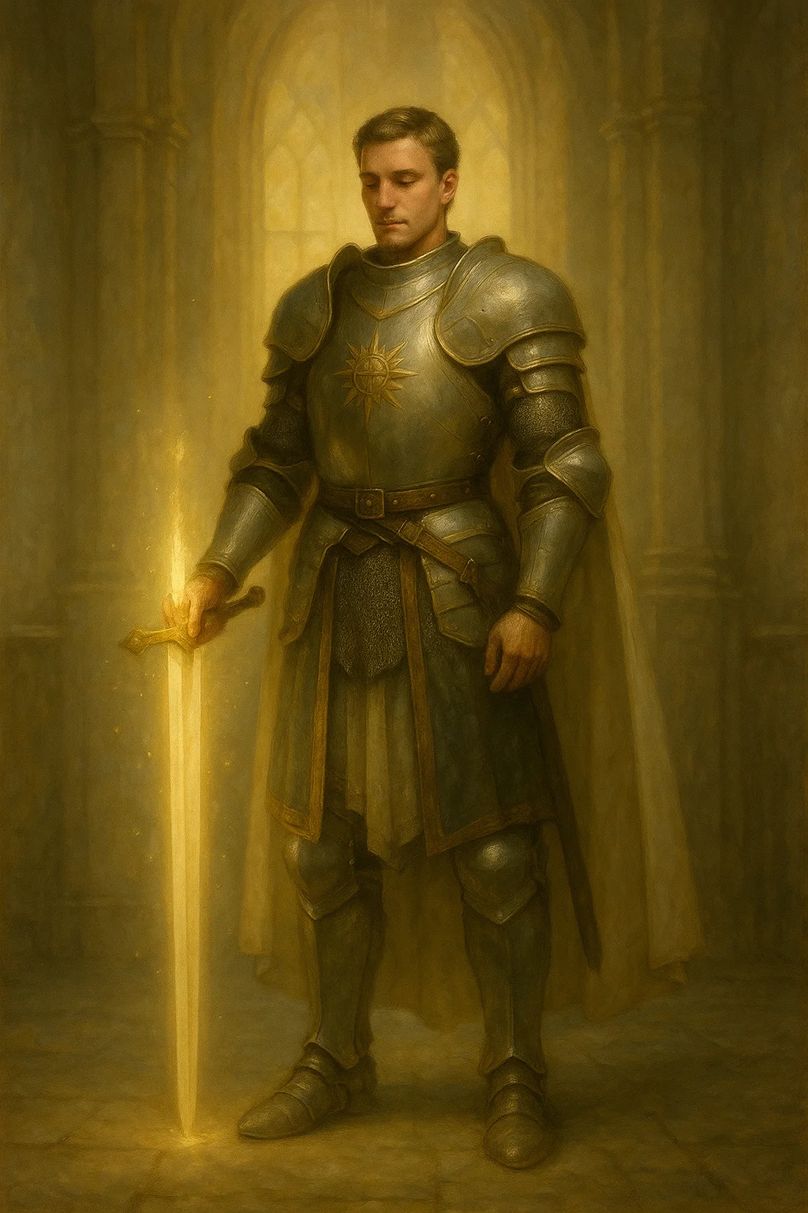

Medium humanoid, lawful good | CR 4

AC 18 (plate) | HP 52 (8d8 + 16) | Speed 30 ft.

|  |  |  |  |  |  |
| --- | --- | --- | --- | --- | --- |
| STR | DEX | CON | INT | WIS | CHA |
| 16 (+3) | 11 (+0) | 14 (+2) | 11 (+0) | 14 (+2) | 16 (+3) |

Saves Wisdom +4, Charisma +5

Skills Religion +2

Senses passive Perception 12

Languages Common

Challenge 4 (1,100 XP)

Divine Health. Immune to disease.

Lay on Hands (20 points). Touch to heal.

**ACTIONS**

Multiattack. Two longsword attacks.

Longsword. Melee Weapon Attack: +5 to hit, reach 5 ft., one target. Hit: 1d8+3 slashing damage

Divine Smite (3/Day). Add 2d8 radiant to hit.

**LORE**

Paladins blessed by the Seven Ascended. Champions of good.

**CAMPAIGN USE**

Allies, mentors, or honorable enemies in either campaign

---

## Thandros's Justicar



Medium humanoid, lawful neutral | CR 6

AC 17 (chain mail, shield) | HP 91 (14d8 + 28) | Speed 30 ft.

|  |  |  |  |  |  |
| --- | --- | --- | --- | --- | --- |
| STR | DEX | CON | INT | WIS | CHA |
| 16 (+3) | 10 (+0) | 14 (+2) | 14 (+2) | 16 (+3) | 14 (+2) |

Saves Wisdom +6, Charisma +5

Skills Insight +6, Persuasion +5

Languages Common

Challenge 6 (2,300 XP)

Divine Authority. Creatures within 30 ft have disadvantage on deception.

Judgment of Thandros. Can cast zone of truth 3/day.

**ACTIONS**

Multiattack. Two mace attacks.

Mace of Justice. Melee Weapon Attack: +6 to hit, reach 5 ft., one target. Hit: 1d6+3 bludgeoning damage + 2d8 radiant damage vs evil

Gavel Strike (Recharge 5-6). DC 14 Wisdom save or stunned 1 round (symbol of law striking).

**LORE**

Chosen enforcers of Thandros, god of law. Hunt criminals and maintain order.

**CAMPAIGN USE**

Complex enemieslawful but could be allies or antagonists

---

## Aethor's Liberator



Medium celestial, chaotic good | CR 7

AC 17 (natural) | HP 136 (16d8 + 64) | Speed 30 ft., fly 90 ft.

|  |  |  |  |  |  |
| --- | --- | --- | --- | --- | --- |
| STR | DEX | CON | INT | WIS | CHA |
| 18 (+4) | 18 (+4) | 18 (+4) | 17 (+3) | 20 (+5) | 20 (+5) |

Saves Wisdom +8, Charisma +8

Skills Insight +8, Perception +8

Damage Resistances radiant; bludgeoning, piercing, slashing from nonmagical

Condition Immunities charmed, frightened | Senses darkvision 120 ft.

Languages all, telepathy 120 ft.

Challenge 7 (2,900 XP)

Magic Resistance. Advantage vs spells and magical effects.

Innate Spellcasting (Charisma, DC 16): At will: knock, dispel magic; 3/day: freedom of movement; 1/day: plane shift

**ACTIONS**

Multiattack. Two mace attacks.

Freedom's Mace. Melee Weapon Attack: +7 to hit, reach 5 ft., one target. Hit: 1d6+4 bludgeoning damage + 4d8 radiant damage

Break All Bonds. All restrained/paralyzed creatures within 30 ft freed automatically.

Change Shape. Can polymorph into humanoid or Medium beast.

**LORE**

Divine servants of Aethor sent to break chains and free the oppressed.

**CAMPAIGN USE**

Major ally in Shattered Oaths, appears at crucial moments

---

## Moira's Seer

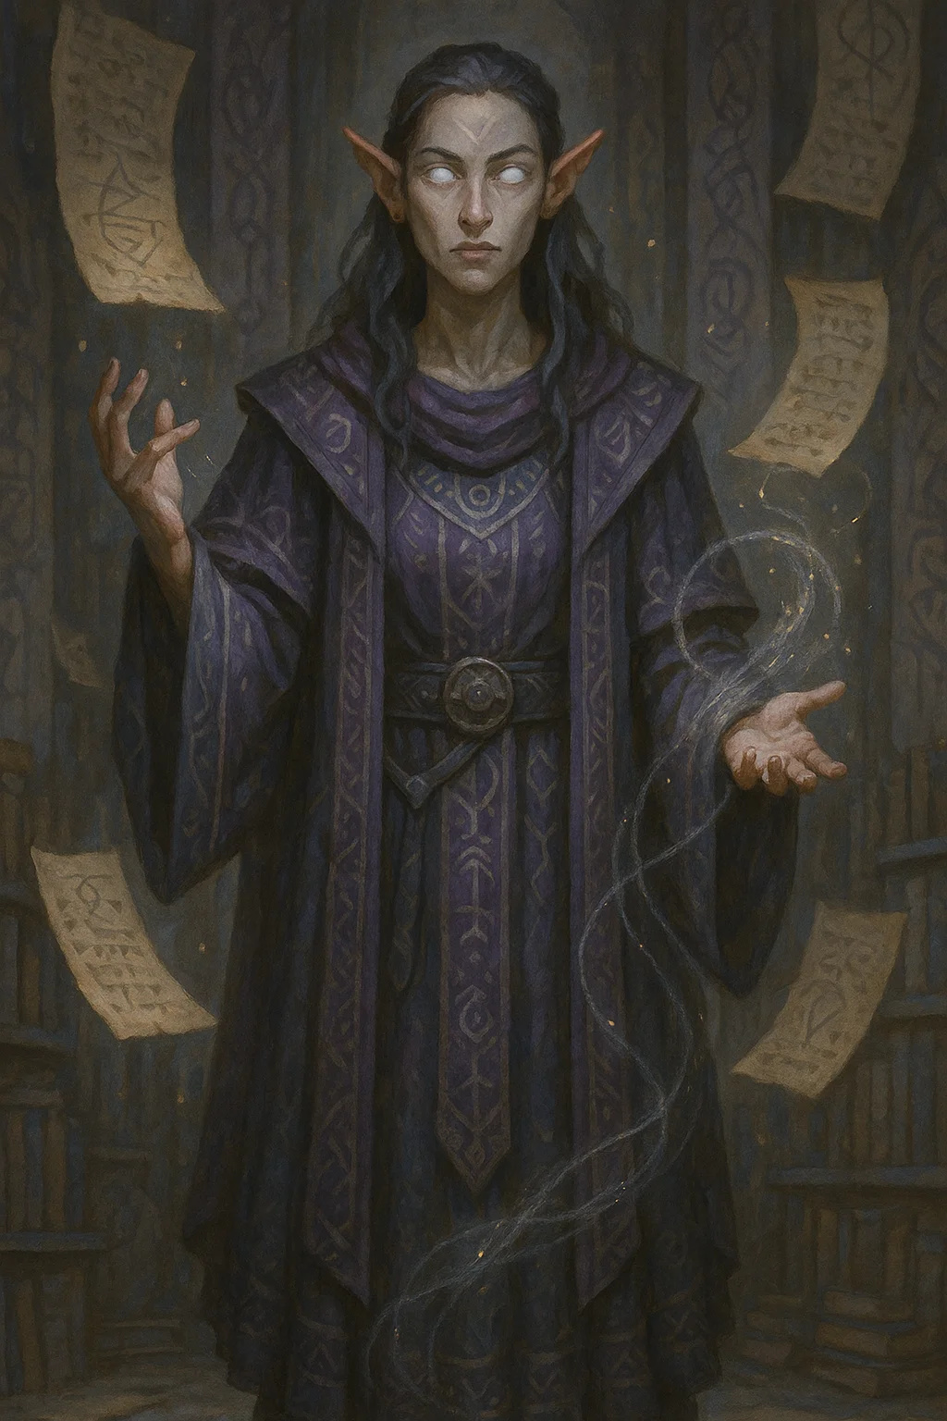

Medium humanoid, any | CR 5

AC 12 (15 with mage armor) | HP 60 (11d8 + 11) | Speed 30 ft.

|  |  |  |  |  |  |
| --- | --- | --- | --- | --- | --- |
| STR | DEX | CON | INT | WIS | CHA |
| 9 (-1) | 14 (+2) | 12 (+1) | 18 (+4) | 20 (+5) | 14 (+2) |

Saves Intelligence +7, Wisdom +8

Skills Arcana +7, History +7, Insight +11

Languages Common +4 others

Challenge 5 (1,800 XP)

Foresight. Can't be surprised. +5 to initiative.

Read Fate. Can cast augury at will, divination 3/day.

**ACTIONS**

Quarterstaff. Melee Weapon Attack: +2 to hit, reach 5 ft., one target. Hit: 1d6-1 bludgeoning

Prophetic Vision (Recharge 5-6). One creature within 60 ft sees possible futures. DC 16 Wisdom save or incapacitated 1 round (overwhelmed by visions).

Weaver's Warning (1/Day). Grant one creature reroll on any d20 within next hour.

**LORE**

Priests of Moira who see threads of fate. Cryptic but helpful.

**CAMPAIGN USE**

Quest givers, prophets who guide heroes in Shattered Oaths

---

## Sylvara's Wild Hunter

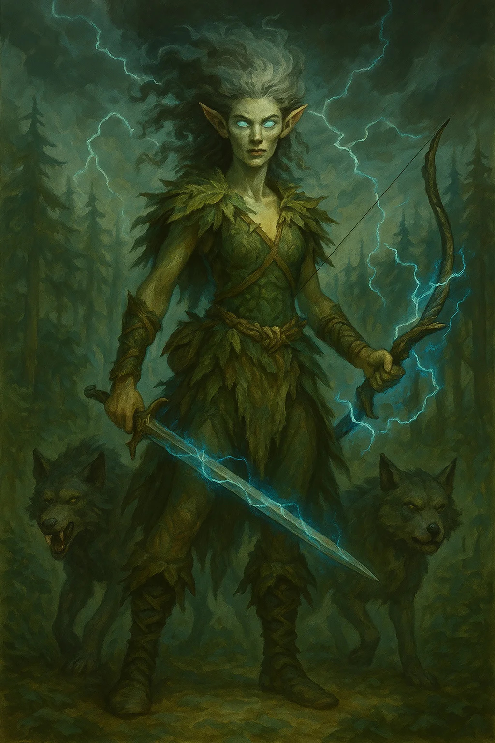

Medium fey, chaotic neutral | CR 8

AC 16 (natural) | HP 127 (15d8 + 60) | Speed 40 ft.

|  |  |  |  |  |  |
| --- | --- | --- | --- | --- | --- |
| STR | DEX | CON | INT | WIS | CHA |
| 18 (+4) | 19 (+4) | 18 (+4) | 14 (+2) | 17 (+3) | 16 (+3) |

Saves Dexterity +7, Wisdom +6

Skills Nature +5, Perception +9, Stealth +10

Damage Resistances lightning, thunder | Senses darkvision 120 ft.

Languages Sylvan, Common

Challenge 8 (3,900 XP)

Wild Empathy. Beasts won't attack unless provoked.

Storm's Fury. When hit, attacker takes 1d8 lightning damage.

**ACTIONS**

Multiattack. Three longbow attacks or two spear attacks.

Spear. Melee Weapon Attack: +7 to hit, reach 5 ft., one target. Hit: 1d6+4 piercing damage + 2d6 lightning damage

Storm Bow. Ranged Weapon Attack: +7 to hit, range 150/600 ft., one target. Hit: 1d8+4 piercing damage + 2d6 lightning damage

Call the Wild (Recharge 5-6). Summon 2d4 wolves (arrive next round, last 1 hour).

Lightning Leap. Teleport up to 60 ft as bonus action, leaving lightning in space (5d6 lightning, DC 15 Dexterity).

**LORE**

Sylvara's chosen hunters. Defend wilderness, punish those who harm nature.

**CAMPAIGN USE**

Guardians of wild places, potential allies if party respects nature

---

## Sera's Mercy

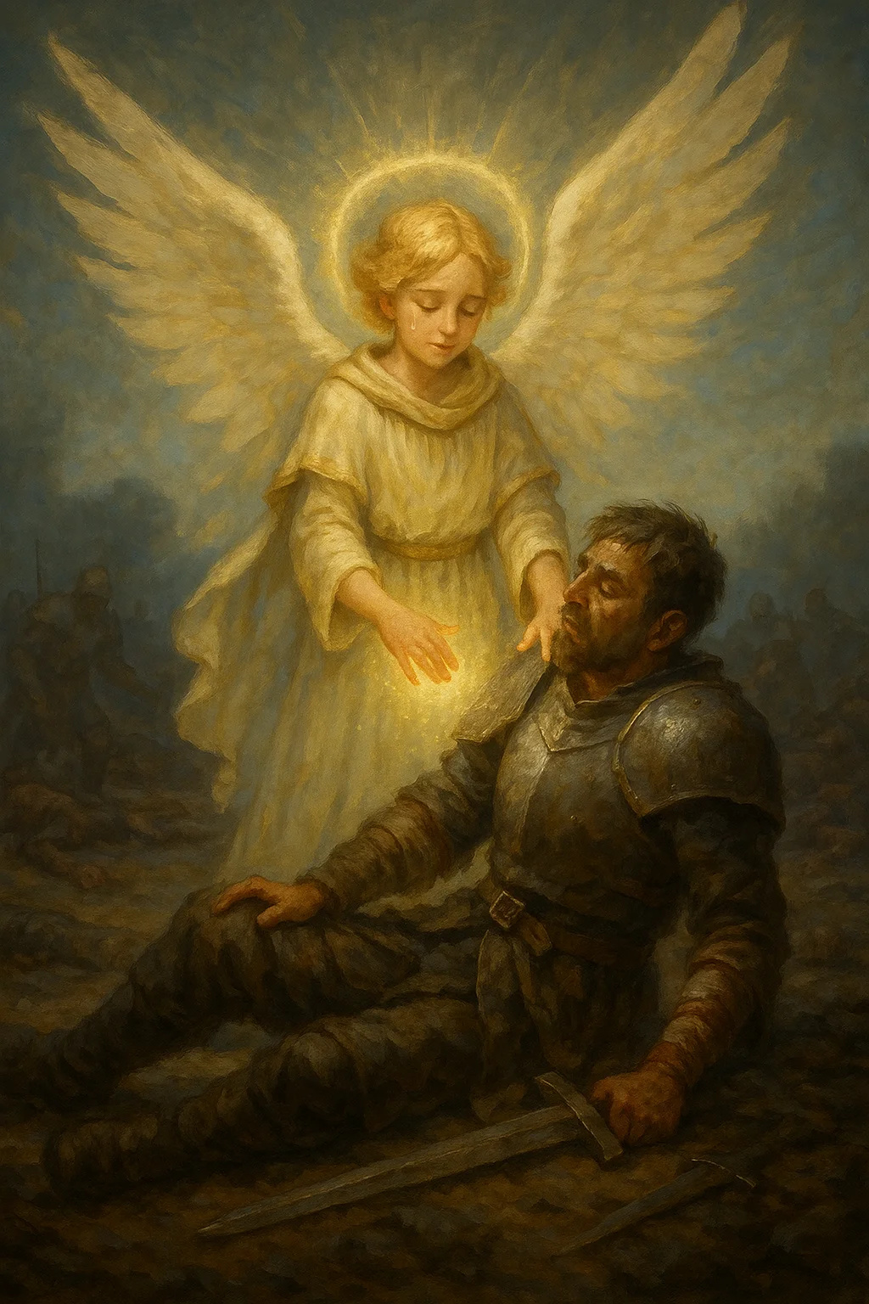

Small celestial, neutral good | CR 3

AC 14 | HP 45 (10d6 + 10) | Speed 30 ft., fly 60 ft.

|  |  |  |  |  |  |
| --- | --- | --- | --- | --- | --- |
| STR | DEX | CON | INT | WIS | CHA |
| 10 (+0) | 18 (+4) | 12 (+1) | 14 (+2) | 18 (+4) | 16 (+3) |

Skills Medicine +8, Insight +6

Damage Resistances radiant

Condition Immunities charmed, frightened | Senses darkvision 60 ft.

Languages all, telepathy 60 ft.

Challenge 3 (700 XP)

Healing Aura (30 ft). Allies regain 5 HP at start of their turn.

Innate Healing: At will: cure wounds (as 1st level); 3/day: lesser restoration; 1/day: raise dead

**ACTIONS**

Touch of Mercy. Melee Weapon Attack: +6 to hit, reach 5 ft., one target. Hit: target healed for 2d8+4 HP or takes 2d8+4 radiant (undead only).

Shield of Compassion (3/Day). Grant one creature within 60 ft resistance to all damage until end of its next turn.

Peaceful Presence (Recharge 6). All creatures within 30 ft make DC 14 Wisdom save or can't attack for 1 minute (charmed effect).

**LORE**

Sera's divine messengers. Heal wounded and offer mercy to repentant.

**CAMPAIGN USE**

Divine healing NPCs, appear when party is in dire need

---

## Mordain's Sentinel

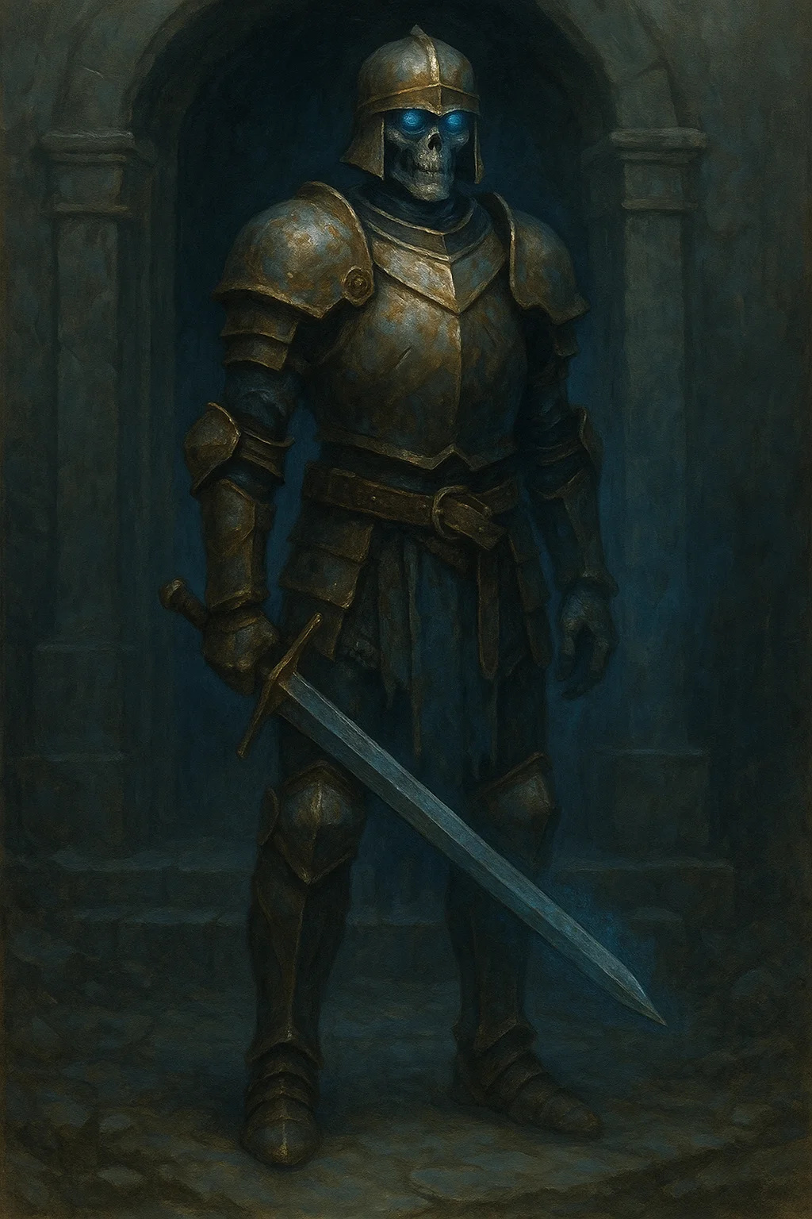

Medium undead, lawful neutral | CR 10

AC 20 (plate, shield) | HP 180 (19d8 + 95) | Speed 30 ft.

|  |  |  |  |  |  |
| --- | --- | --- | --- | --- | --- |
| STR | DEX | CON | INT | WIS | CHA |
| 20 (+5) | 11 (+0) | 20 (+5) | 12 (+1) | 16 (+3) | 18 (+4) |

Saves Strength +9, Constitution +9, Wisdom +7 | Damage Immunities necrotic, poison

Condition Immunities exhaustion, frightened, poisoned | Senses darkvision 120 ft.

Languages Common

Challenge 10 (5,900 XP)

Eternal Vigil. Can't be surprised. Immune to sleep.

Turn Immunity. Can't be turned.

Magic Resistance. Advantage vs spells.

**ACTIONS**

Multiattack. Three longsword attacks.

Longsword of Vigil. Melee Weapon Attack: +9 to hit, reach 5 ft., one target. Hit: 1d8+5 slashing damage + 3d8 necrotic damage

Sentinel's Command (Recharge 5-6). All undead within 60 ft gain +2 AC and advantage on attacks for 1 min.

Honor the Fallen (1/Day). All dead within 30 ft rise as shadows under sentinel's control for 1 hour.

**LORE**

Mordain's chosen guardians. Protect sacred sites and honor the dead.

**CAMPAIGN USE**

Guard important tombs, test heroes' worthiness in Shattered Oaths

---

## Fallen Champion

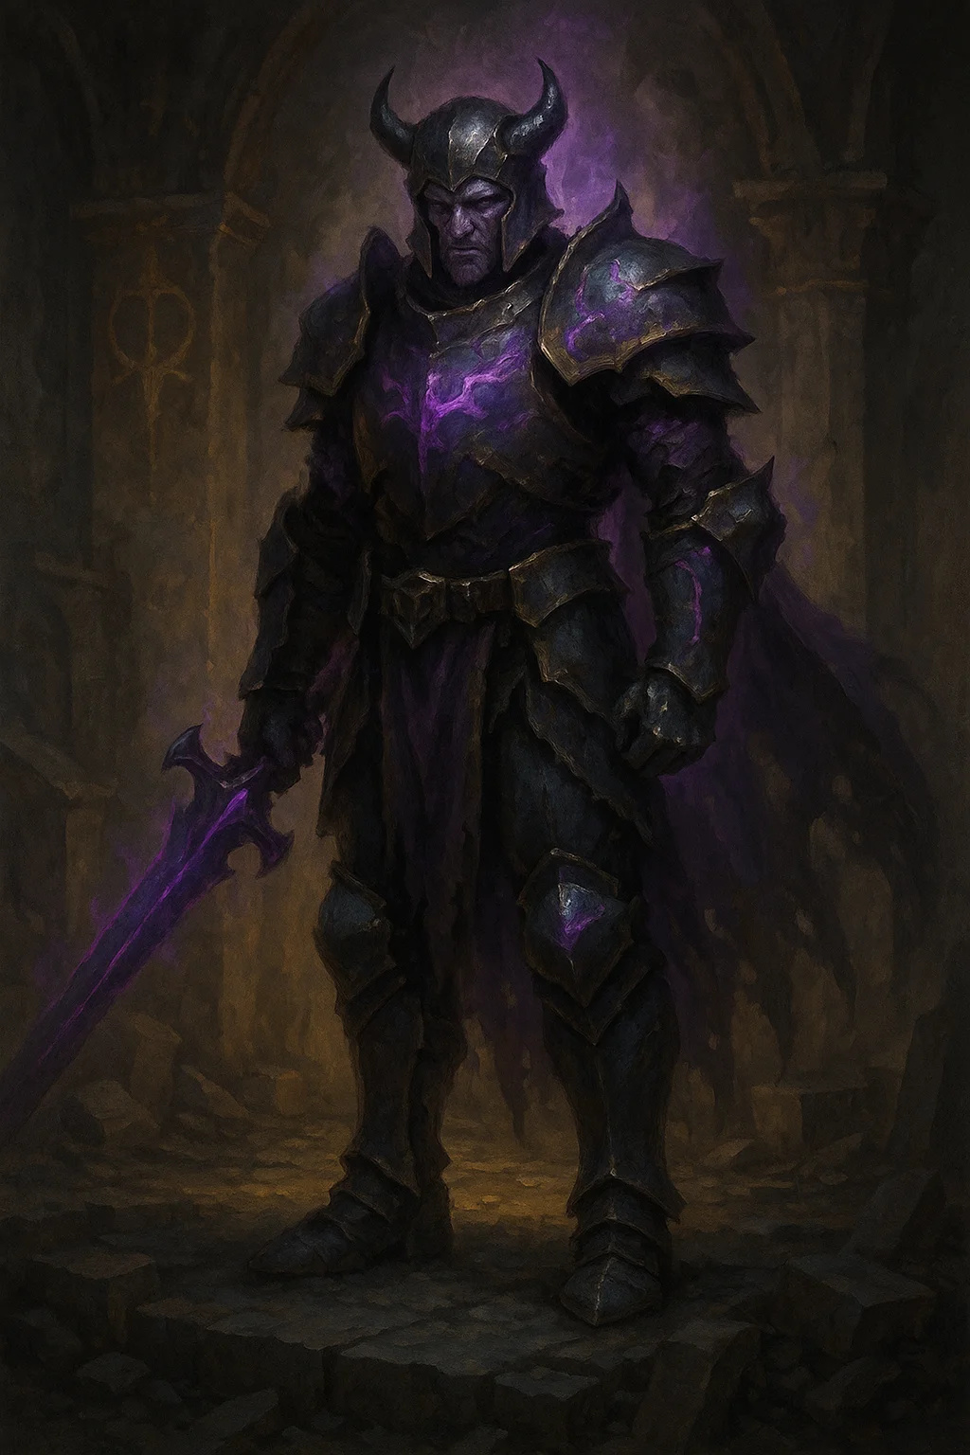

Medium undead, any evil | CR 9

AC 18 (plate) | HP 135 (18d8 + 54) | Speed 30 ft.

|  |  |  |  |  |  |
| --- | --- | --- | --- | --- | --- |
| STR | DEX | CON | INT | WIS | CHA |
| 18 (+4) | 12 (+1) | 16 (+3) | 11 (+0) | 12 (+1) | 14 (+2) |

Saves Strength +8, Constitution +7 | Damage Immunities poison

Condition Immunities exhaustion, poisoned | Senses darkvision 60 ft.

Languages Common

Challenge 9 (5,000 XP)

Corrupted Divine. Was once blessed by the Ascended but fell. Retains some divine power.

Desecrated Ground. Area within 30 ft is cursed. Living creatures have disadvantage on saves.

**ACTIONS**

Multiattack. Three greatsword attacks.

Cursed Greatsword. Melee Weapon Attack: +8 to hit, reach 5 ft., one target. Hit: 2d6+4 slashing damage + 2d8 necrotic damage

Aura of Despair (Recharge 5-6). All creatures within 30 ft make DC 15 Wisdom save or frightened 1 min. Frightened creatures have speed 0.

Corrupted Smite (3/Day). Add 4d8 necrotic to attack.

**LORE**

Heroes who broke their oaths or fell to corruption. Tragic enemies.

**CAMPAIGN USE**

Moral complexitythey were heroes once. What went wrong? Can they be redeemed?

# Ancient & Prophecy

## Ancient Guardian

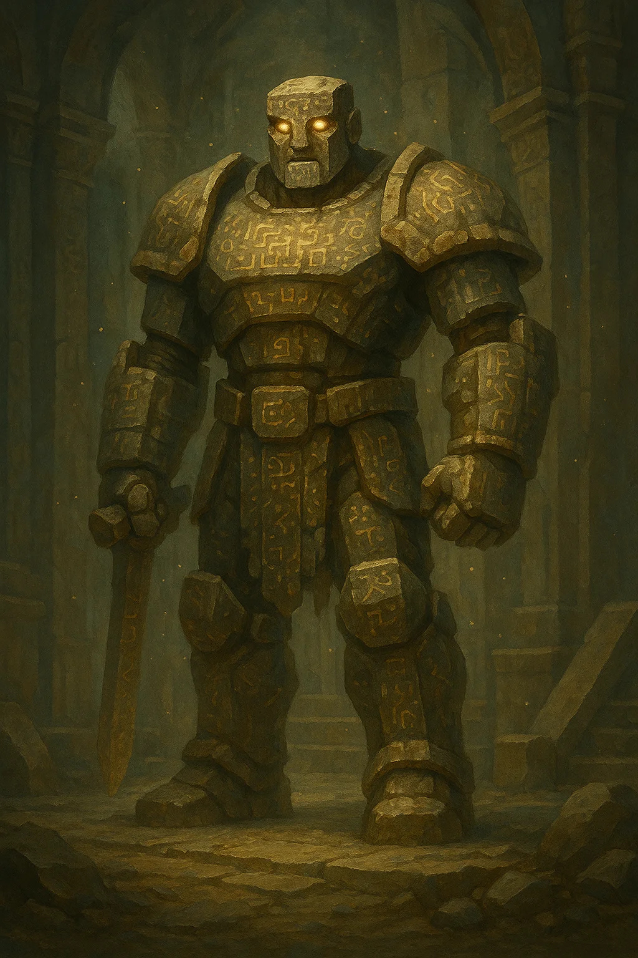

Large construct, neutral | CR 8

AC 17 (natural) | HP 178 (17d10 + 85) | Speed 20 ft.

|  |  |  |  |  |  |
| --- | --- | --- | --- | --- | --- |
| STR | DEX | CON | INT | WIS | CHA |
| 22 (+6) | 9 (-1) | 20 (+5) | 10 (+0) | 11 (+0) | 1 (-5) |

Damage Immunities poison, psychic; nonmagical weapons

Condition Immunities charmed, exhaustion, frightened, paralyzed, petrified, poisoned

Senses darkvision 120 ft., truesight 30 ft.

Languages understands Ancient tongue

Challenge 8 (3,900 XP)

Immutable Form. Immune to form-altering effects.

Magic Resistance. Advantage vs spells.

Prophetic Inscription. Body covered in ancient prophecies. Creatures who read them gain knowledge (or madness).

**ACTIONS**

Multiattack. Two slam attacks.

Slam. Melee Weapon Attack: +9 to hit, reach 10 ft., one target. Hit: 3d8+6 bludgeoning damage

Time Ripple (Recharge 5-6). All creatures in 20 ft radius make DC 16 Wisdom save. Failed save: sent forward in time 1 round (miss turn, reappear in same space). Success: take 4d10 psychic damage.

**LORE**

Ancient constructs guarding prophetic sites. Test those who seek knowledge.

**CAMPAIGN USE**

Guardians of temples, sources of prophecy clues in Shattered Oaths

---

## Prophecy Keeper

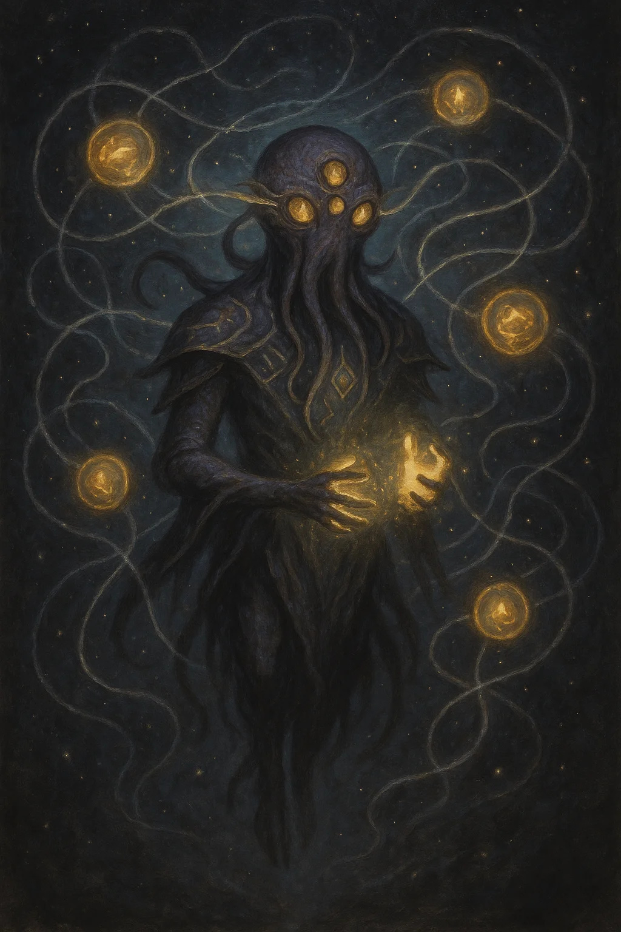

Medium aberration, lawful neutral | CR 10

AC 15 (natural) | HP 142 (15d8 + 75) | Speed 0 ft., fly 40 ft. (hover)

|  |  |  |  |  |  |
| --- | --- | --- | --- | --- | --- |
| STR | DEX | CON | INT | WIS | CHA |
| 10 (+0) | 20 (+5) | 20 (+5) | 22 (+6) | 22 (+6) | 18 (+4) |

Saves Intelligence +10, Wisdom +10, Charisma +8

Skills Arcana +14, History +14

Damage Resistances psychic | Senses truesight 120 ft., passive Perception 16

Languages all, telepathy 120 ft.

Challenge 10 (5,900 XP)

Keeper of Fate. Knows all events related to Shattered Oath prophecy.

Unchangeable. Immune to chronomancy and fate-altering magic.

Innate Spellcasting (Wisdom, DC 18): At will: detect thoughts, legend lore; 3/day: scrying, modify memory; 1/day: foresight

**ACTIONS**

Multiattack. Three psychic lance attacks.

Psychic Lance. Ranged Weapon Attack: +10 to hit, range 120 ft., one target. Hit: 3d10+5 psychic damage

Reveal Fate (Recharge 5-6). Show one creature their destined future. DC 18 Wisdom save or stunned 1d4 rounds (overwhelming vision). On success, gain advantage on next d20 roll.

Alter Memory (3/Day). As modify memory spell.

**LORE**

Cosmic entities who record prophecies. Neutralthey just observe and remember.

**CAMPAIGN USE**

Sources of prophecy knowledge, tests for heroes in Shattered Oaths

---

## Forgotten King

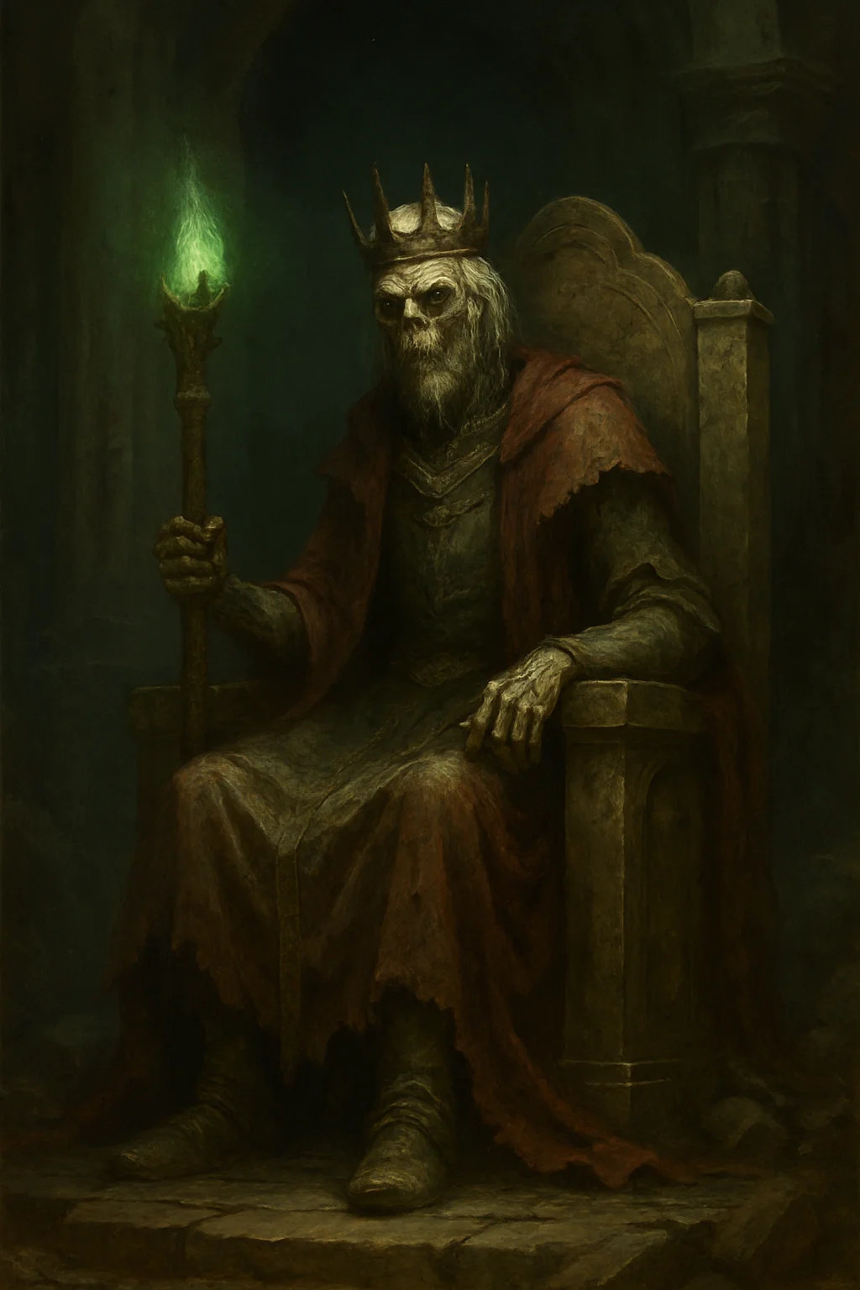

Medium undead, neutral evil | CR 15

AC 17 (natural) | HP 135 (18d8 + 54) | Speed 30 ft.

|  |  |  |  |  |  |
| --- | --- | --- | --- | --- | --- |
| STR | DEX | CON | INT | WIS | CHA |
| 11 (+0) | 16 (+3) | 16 (+3) | 20 (+5) | 14 (+2) | 16 (+3) |

Saves Constitution +9, Intelligence +11, Wisdom +8

Skills Arcana +17, History +17

Damage Resistances cold, lightning, necrotic

Damage Immunities poison; nonmagical weapons

Condition Immunities charmed, exhaustion, frightened, paralyzed, poisoned

Senses truesight 120 ft.

Languages Common +10 others

Challenge 15 (13,000 XP)

Legendary Resistance (3/Day). Choose to succeed on failed save.

Paralyzing Touch. Creatures hit by touch must save or be paralyzed.

Spellcasting. 18th-level wizard (DC 19, +11 attack). Has all wizard spells prepared.

**ACTIONS**

Touch of Death. Melee Weapon Attack: +8 to hit, reach 5 ft., one target. Hit: 3d6 cold damage + 3d6 necrotic damage. DC 17 Constitution save or paralyzed 1 min.

Crown of Forgotten Kings (Recharge 5-6). All creatures within 60 ft make DC 19 Wisdom save or forget their purpose (confusion effect) for 1 min.

**LEGENDARY ACTIONS (3/round):**

Cantrip. Cast a cantrip

Move. Fly up to half speed

Cast Spell (2 actions). Cast spell of 1st-3rd level

Summon Undead (3 actions). 1d6 wraiths appear

**LORE**

Ancient king whose dynasty fell. Part of the original "Seven" who failed. His throne is prophesied to be reclaimed.

**CAMPAIGN USE**

Major villain in Shattered Oaths final act, tied directly to prophecy

---

## Herald Of The Seven



Large celestial, lawful good | CR 12

AC 19 (natural) | HP 200 (16d10 + 112) | Speed 40 ft., fly 120 ft.

|  |  |  |  |  |  |
| --- | --- | --- | --- | --- | --- |
| STR | DEX | CON | INT | WIS | CHA |
| 24 (+7) | 20 (+5) | 24 (+7) | 19 (+4) | 22 (+6) | 25 (+7) |

Saves Constitution +12, Wisdom +11, Charisma +12

Skills Insight +11, Perception +11

Damage Resistances radiant; nonmagical weapons

Condition Immunities charmed, exhaustion, frightened | Senses truesight 120 ft.

Languages all, telepathy 120 ft.

Challenge 12 (8,400 XP)

Divine Awareness. Knows if creature within 60 ft lies.

Magic Resistance. Advantage vs spells.

Innate Spellcasting (Charisma, DC 20): At will: detect evil and good, invisibility (self); 3/day: blade barrier, flame strike, raise dead; 1/day: commune, control weather

**ACTIONS**

Multiattack. Two greatsword attacks.

Greatsword of the Seven. Melee Weapon Attack: +12 to hit, reach 5 ft., one target. Hit: 4d6+7 slashing damage + 5d8 radiant damage

Ascended's Command (Recharge 5-6). Issue divine command. All creatures within 60 ft must obey one-word command (as command spell) if they fail DC 20 Wisdom save.

Healing Touch (4/Day). Touch heals 6d8+7 HP and removes all conditions.

**LORE**

Direct messenger of the Seven Ascended. Appears during pivotal moments.

**CAMPAIGN USE**

Divine intervention, major ally, deliver prophecy in Shattered Oaths

---

# Corrupted & Cursed

## Corruption Spawn



Small aberration, chaotic evil | CR 4

AC 9 | HP 67 (9d6 + 36) | Speed 10 ft., swim 10 ft.

|  |  |  |  |  |  |
| --- | --- | --- | --- | --- | --- |
| STR | DEX | CON | INT | WIS | CHA |
| 10 (+0) | 8 (-1) | 18 (+4) | 3 (-4) | 10 (+0) | 6 (-2) |

Condition Immunities prone | Senses darkvision 60 ft.

Languages

Challenge 4 (1,100 XP)

Aberrant Ground. Area within 10 ft is difficult terrain (reality distorts).

Gibbering. Creatures starting turn within 20 ft hear mad babbling. DC 10 Wisdom save or can't take reactions until their next turn.

**ACTIONS**

Multiattack. One bite, one spitting attack.

Bites. Melee Weapon Attack: +2 to hit, reach 5 ft., one target. Hit: 5d6 piercing damage

Spit Corruption. Ranged Weapon Attack: +2 to hit, range 15/30 ft., one target. Hit: 3d6 acid damage

Blinding Spittle (Recharge 5-6). Spit at point within 15 ft. 5-ft radius, DC 13 Dexterity save or blinded 1 min.

**LORE**

Spawn of war magic gone wrong. Corrupted by dark energies. Mindless and hungry.

**CAMPAIGN USE**

Consequences of war crimes, horror elements in both campaigns

---

## War Twisted Soldier

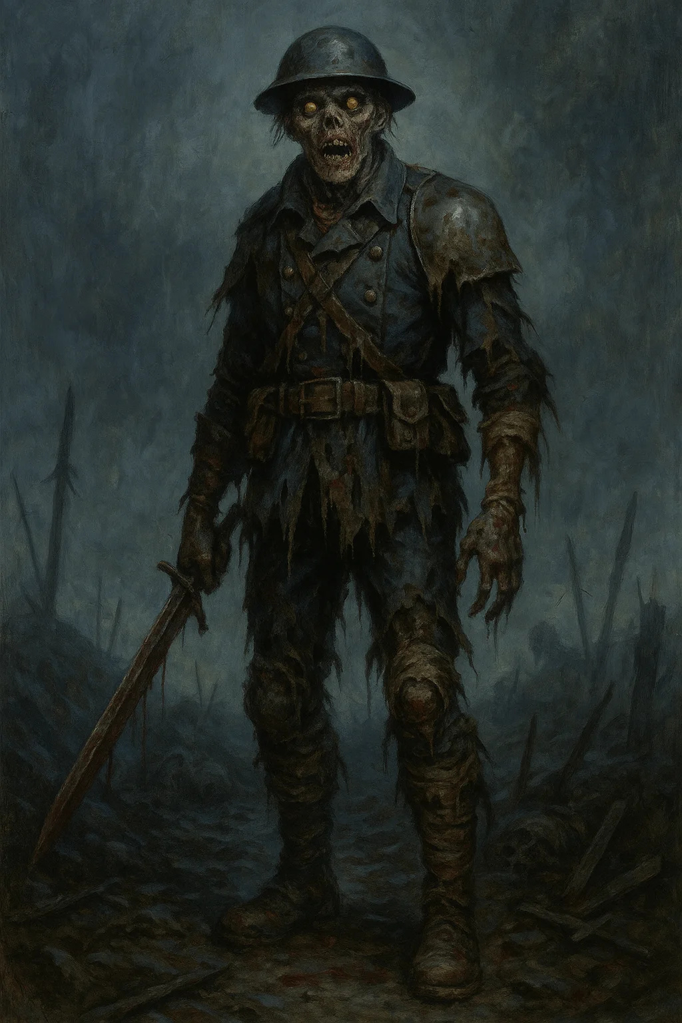

Medium undead, neutral evil | CR 6

AC 14 (armor scraps) | HP 97 (13d8 + 39) | Speed 30 ft.

|  |  |  |  |  |  |
| --- | --- | --- | --- | --- | --- |
| STR | DEX | CON | INT | WIS | CHA |
| 18 (+4) | 14 (+2) | 16 (+3) | 10 (+0) | 12 (+1) | 9 (-1) |

Saves Constitution +6

Skills Perception +4, Stealth +5

Damage Resistances necrotic; bludgeoning, piercing, slashing from nonmagical

Damage Immunities poison | Condition Immunities exhaustion, poisoned

Senses darkvision 60 ft.

Languages Common

Challenge 6 (2,300 XP)

Sunlight Sensitivity. Disadvantage in sunlight.

War Instinct. Advantage on initiative and can't be surprised.

Create Spawn. Humanoid killed by this creature rises as war-twisted soldier in 24 hours unless blessed or burned.

**ACTIONS**

Multiattack. Two longsword attacks and one life drain.

Longsword. Melee Weapon Attack: +7 to hit, reach 5 ft., one target. Hit: 1d8+4 slashing damage

Life Drain. Melee Weapon Attack: +7 to hit, reach 5 ft., one target. Hit: 2d6+4 necrotic. Target max HP reduced by amount (until long rest). Dies if max HP reaches 0.

Battle Cry (Recharge 6). All war-twisted soldiers within 30 ft can attack as reaction.

**LORE**

Soldiers who died violently and rose as undead, twisted by rage and trauma.

**CAMPAIGN USE**

Horror of war, undead encounters in cursed battlefields

---

## Curse Bearer

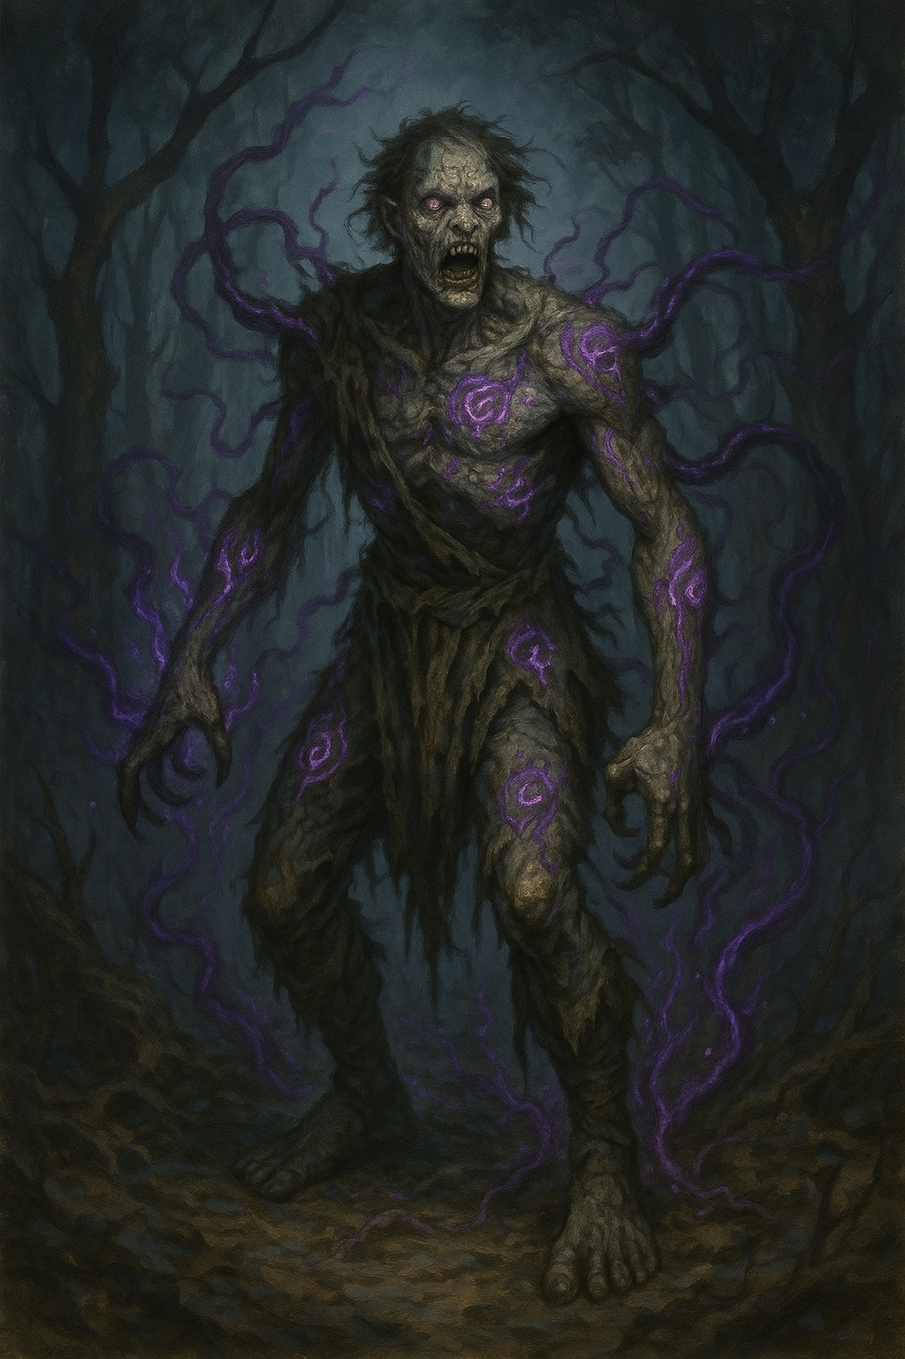

Large monstrosity, chaotic evil | CR 8

AC 15 (natural) | HP 126 (12d10 + 60) | Speed 40 ft., climb 40 ft.

|  |  |  |  |  |  |
| --- | --- | --- | --- | --- | --- |
| STR | DEX | CON | INT | WIS | CHA |
| 19 (+4) | 16 (+3) | 20 (+5) | 8 (-1) | 14 (+2) | 10 (+0) |

Saves Constitution +8, Wisdom +5

Skills Perception +5, Stealth +6

Damage Resistances necrotic | Senses darkvision 120 ft., blindsight 30 ft.

Languages understands Common but can't speak

Challenge 8 (3,900 XP)

Cursed Form. Creature cursed by Haunted Battlefield or dark magic. Now hunts living.

Aura of Misfortune (30 ft). Living creatures have disadvantage on saving throws.

Spider Climb. Can climb difficult surfaces without check.

**ACTIONS**

Multiattack. Two claw attacks and one bite.

Claw. Melee Weapon Attack: +7 to hit, reach 10 ft., one target. Hit: 2d6+4 slashing damage

Bite. Melee Weapon Attack: +7 to hit, reach 5 ft., one target. Hit: 2d8+4 piercing damage + 2d8 necrotic damage

Curse Touch (Recharge 5-6). One creature within 5 ft makes DC 15 Wisdom save or cursed. Cursed creature has disadvantage on all d20 rolls for 1 hour. Remove curse ends it.

Terrifying Howl (1/Day). All creatures within 60 ft make DC 15 Wisdom save or frightened 1 min. Can repeat save each turn.

**LORE**

Result of powerful curses or exposure to corrupted magic. Was once human or beast.

**CAMPAIGN USE**

Horror element, consequences of dark magic, boss for mid-level party